Canterbury/ Aoraki Schools SLopestyle
In association with Mt Hutt parks and School Sport Canterbury

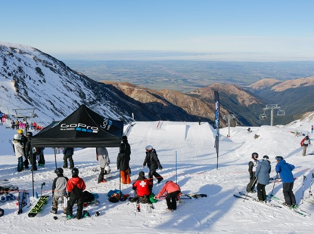

Slopestyle is a type of winter sporting event where the goal is to perform the most difficult tricks while getting the highest amplitude off of jumps, with an emphasis on performing different types of tricks instead of doing one great trick repeatedly.

CONDITIONS OF ENTRY

Each school coordinator prior to entering a student in the event must deem that the student has the appropriate level of skill and experience to compete. Questions that must be asked by each coordinator are:
• Can you execute a controlled straight air on a ‘green’ or ‘S’ (Small) category jump?
• Can you execute a controlled 50/50 (snowboard) or straight grind (skier) on a 5 metre box?
• Do you have the ability to ride/ ski switch in a controlled way down a blue run?
Previous competition experience and or coaching/ lessons in terrain parks may be taken into account by the School Coordinator to assess appropriate skill level.
School teams will consist of the top 2 scores from each team in allocated section. Eg Female Skier Mt Hutt College. There will be a maximum of 5 athletes per school team in any one section.

COURSE FORMAT

• The course will be set suitable for this level of competition by the mountain Terrain Park Department. Course locations at each resort will be on resort and Interschools approved terrain locations to ensure that appropriate speeds are not exceeded.
• Competitors must wear race bibs, and helmets during practice and competition.
• The Interschools Slopestyle courses consist of two jumps with varying levels of take-off difficulty provided on each jump. Two boxes/jib features will also be installed on the course with easier and more challenging entries onto the boxes provided.
• Each training and competition run start will be controlled by the appointed chief of course/starter. Each jump will have a volunteer stationed on the jump to close the jump in the event of a fall.

COMPETITION FORMAT
• Each competitor will have at least one training run on the course.
During the allocated training time competitors may have as many training runs that the training time permits under the starters directions. Each competitor will have two competition runs with the best of the two runs counting toward individual and team results. In the event of delays, snow conditions or visibility issues the event may be run as a one run only event. Slopestyle events are judged events with no timing component.
• Each competitors run will be judged by a minimum of three judges. One head judge and two additional judges who will each give a score out of 100 (known as an overall impression score). The final score will be the average of the three scores.

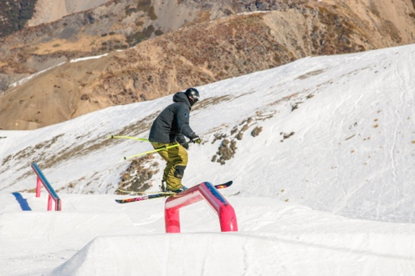

JUDGING FORMAT OVERALL IMPRESSION
(3 JUDGE FORMAT) 3 Judges will nominate a score out of a total maximum of 100.

FINAL SCORE = Average of 3 judges scores.
Example: JUDGE 1 = 75
; JUDGE 2 = 82
; JUDGE 3 = 71 SCORE = 228/3 FINAL SCORE = 76 SCORE CATEGORIES •
Below Average Execution: 1 – 45 points
• Average Execution: 45 – 60 points
• Good Execution: 60 – 80 points
• Excellent Execution: 80 – 100 points CRITERIA

Judging Criteria guidelines -
https://www.redbull.com/ca-en/how-to-judge-snowboard-slopestyle

The Line

The line the competitor takes through the course – If there are options to choose on course features in regards to take offs then this is the course ‘line’. The judges will take into account if the competitor has chosen a more difficult or less difficult line. Use of Terrain Features The use of the terrain features on the course
– How the competitor uses the jib features and the difficulty and variety shown. Judges consider:
• Switch take offs or landings
• Direction of rotation (left/right, natural/unnatural, frontside/backside)
• Variety of grabs
• Trick sequence and combination of tricks
• Different rotation axis
• Entry, exit, position and movement on jib features Preforming grabs can change the difficulty of the trick. Boning or tweaking can increase the difficulty as can where you grab on the board or skis and with what hand with respect to the rotation. Amplitude, Style and Overall Flow Amplitude is not just going “BIG” on the kickers but landing at the “sweet spot”.
Showing good amplitude on jumps is by “popping” and having good trajectory in the air. Execution is a major consideration with style and impacts the overall flow of the run. Style and flow is evident through control maintained during the whole run, from start to finish. Competitors should ride with good stability and fluidity through each feature, take-off and landing. Each trick should “look easy”. If the intention of a grab is shown, the grab should be made on the board or skis and not anywhere else, ie. Not on the boots or bindings.

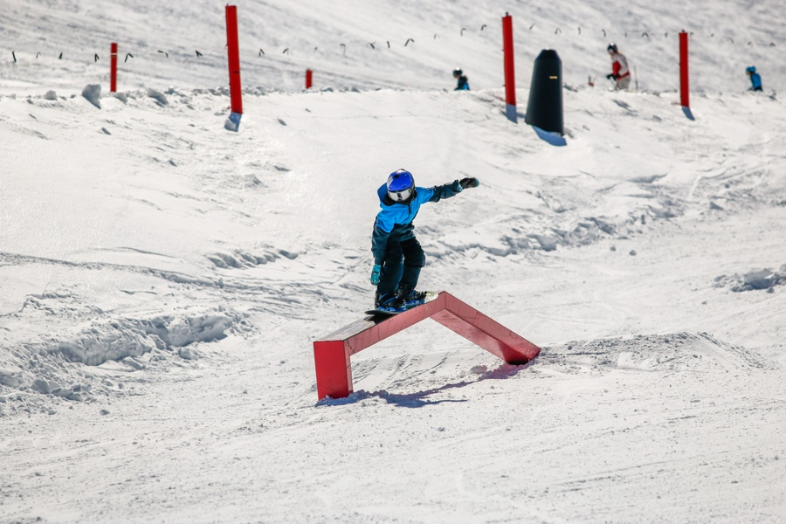

INTERSCHOOLS SLOPESTYLE RULES START ORDERS AND PROCEDURES
• The starting order will be determined by a draw whereby for each Division, Team A from each school will be drawn first, followed by Team B from each school and so on.
• The competition will proceed in the numerical order of bib.
• A competitor who is late for a start will compete at the end of the Division. RACE PROCEDURES
• All competitors must be present for the competitor briefing 10 minutes prior to course inspection. Any absent competitors at the competitor briefing may be disqualified from the event.
• The competitor must remain within the marked (fenced) course. If the boots of the competitor cross out of bounds or the competitor does not pass through the finish line, then the competitor will receive a score up to the point where they left the course.
• If obstructed during his or her run by an official, spectator, animal, another competitor who has fallen and has not cleared the course, objects left on the course or First Aid measures, the competitor must immediately leave the course, hold one arm up in the air to signal the obstruction, go to the bottom of the course, consult the Head Judge and request a re-run.
• A provisional re-run will be granted immediately and will be valid only if it is confirmed by the Chief of Course at the conclusion of that run. If the claim for the re-run is shown to be unjustified, the competitor’s re-run will not be counted.
• The competitor will be judged according to their performance. If a competitor stops in the course for more than 10 seconds, the competitor should exit the course as soon as possible and will be scored to that point. DISQUALIFICATIONS Reasons for disqualification include:
• Reasons for disqualification may include: skiing/riding without correct bibs, false name, accepting outside help in a run (ie: after a fall), unjustifiable requests for a re-run, skiing/riding off designated course, performing somersaults (inverts), unsportsmanlike behaviour/ conduct or being absent at competitor briefing and course inspection
• Competitors who believe they will be disqualified should check with the Head Judge who will check with the appropriate official.
• Disqualifications are at the discretion of the respective Chief of Competition and/or jury.
• A competitor who does not demonstrate sufficient competency in the opinion of the Jury may be asked to leave the course.
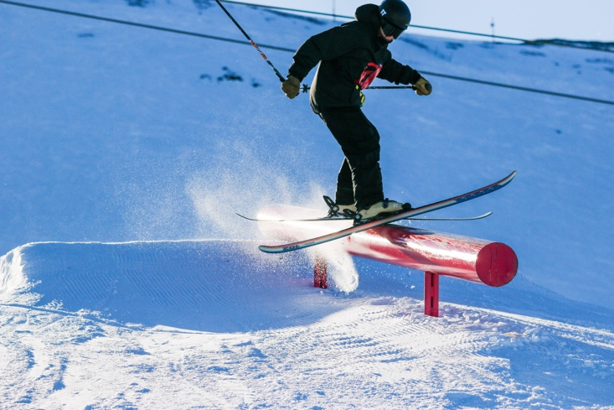
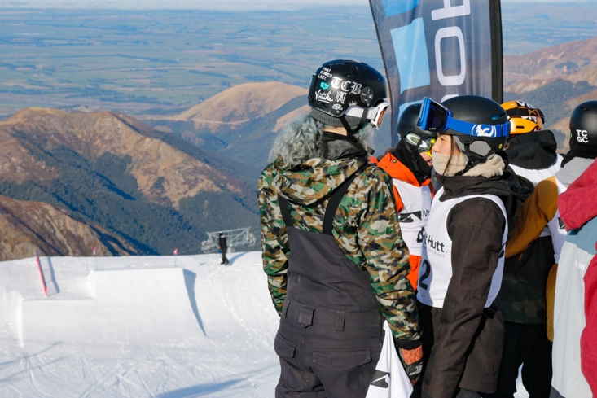
• For details on Protest Procedures, refer to General Rules. PROCEDURES AT FINISH The competitor, after crossing the finish line, must turn and show their bib number to the Finish Referee, then immediately leave the run out zone. The run out zone is a dangerous area and must be kept clear at all times. Spectators and Team Managers are forbidden to be in this zone.
