[Grab your reader’s attention with a great quote from the document or use this space to emphasize a key point. To place this text box anywhere on the page, just drag it.]



***2022 Canterbury Secondary Schools Road Race Championships***

**North Hagley Park**

**Running anticlockwise**

**1k - 2/3rds of a lap**

**2k - 1 & 1/3rd laps**

**3k - just under 2 laps**

**4k - 2 & 1/2 laps**

**Para 1k – 12.40pm**

**Para 2k – 1.10pm**

**Y9 Boys 3k – 1.30pm**

**Y9 Girls 3k - 1.31pm**

**U16 Boys 3k – 1.55pm**

**U16 Girls 3k – 1.56pm**

**U/19 Boys 4k – 2.15pm**

**U/19 Girls 3k – 2.15pm**

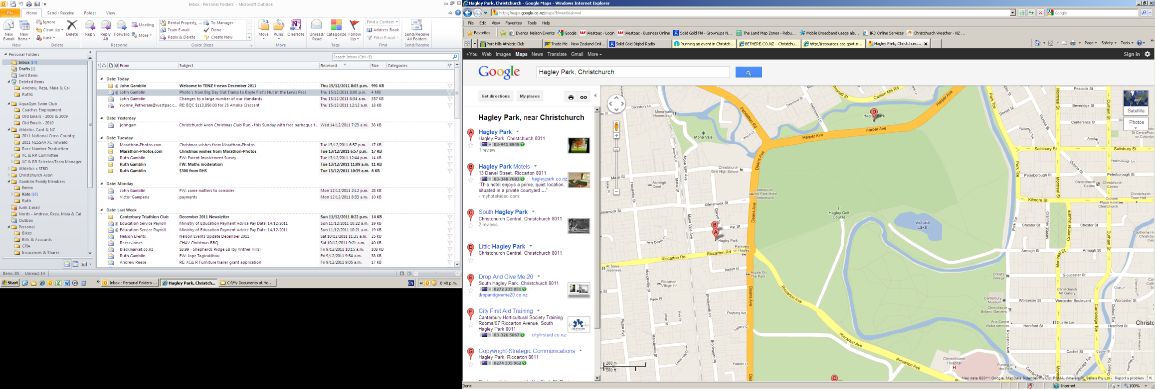

**Finish**

Toilets

Toilets

Parking

Parking

Parking

Parking

Parking

**North Hagley Park**

Parking

**3k Start**

**1k Start**

**4k Start**

**2k Start**

**Evacuation Area**