Christchurch School Cycling Affiliation and Racing Dates 2021
Life begins again for school cycling. We have a full programme for the year. there are some format and event changes this year.
We have added a 2 person time trial series for schools which cannot field 3 riders.
Due to the difficulties with fielding teams of 5 riders our local time trial series will revert to 4 riders with 3 to finish.
At the pre Nationals event teams will be able to ride with 5 riders.
Schools Road nationals are in Timaru which again is a great opportunity for South Island riders.
School cycling is expanding and Cyclocross has been added to the schools programme. Excitingly the first ever South Island CX Championship will be in Christchurch on 24 July ... Watch this space!!
Christchurch School Cycling Affiliation and Racing Dates 2021
Affiliation
Schools need to be affiliated to Cycling New Zealand Schools. This enables Schools to compete in all local, regional, island and National Schools Road Track MTB and CX racing. (This does not include race entry fees)
https://schools.cyclingnewzealand.nz/affiliation-licensing/#:~:text=The%202021%20affiliation%20fees%20are,New%20Zealand%20Schools%20events%20only.
Racing (* individual points racing days.)
May
12 Registration Day
19 Individual Time Trial - 8 km (Seeding event)*
26 Graded Scratch -l2km & 8km*
June
02 Graded Scratch -l2km&8km*
09 Graded Scratch -12 km & 8 km*
16 4 Person Teams Time Trial - (Scotty Browns Teams Series Round 1)
2 Person Teams Time Trial Round 1
23 Hill Climb Time Trial - 2.3 km (Kennedys Bush Road)*
30 Graded Scratch -l2km & 8km*
July
07 Individual Time Trial - 8 km*
10 [Saturday]
Cycling New Zealand Schools South Island Road Championships (subject to a separate Health & Safety Plan)
Mike Pero Raceway Christchurch
Races all age groups Boys & Girls. (Time Trials & Teams Races)
Also Scotty Browns Teams Series (Round 2)
11 [Sunday]
Mike Pero Raceway Christchurch Races all age groups boys & girls. [Scratch Races]
14 & 21 July – NO RACING-TERM BREAK
July
24 South Islands Schools Cyclocross Champs
28 Graded Scratch - 12 km & 8 km*
August
04 4 Person Teams Time Trial - (Scotty Browns Teams Series Round 3)
2 Person Teams Time Trial Round 2
11 Graded Scratch - 12 km & 8 km*
18 Canterbury Schools Teams Championships -15 km. [Teams of 4] Litolff - Dawe - Searle & Webb Cups - Tai Tapu Hotel 2.00 pm Start (Also Scotty Browns Teams Series Round 4) & 2 Person Teams Time Trial Round 3
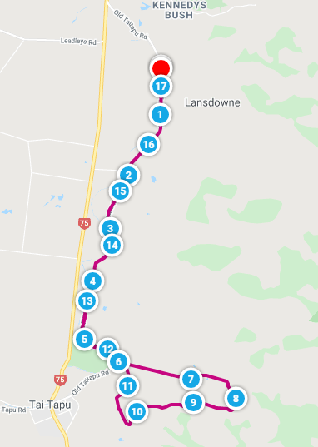
25 Graded Scratch - 12 km & 8 km*
28-29 Southern Tour Blenheim
September
01 Graded Scratch - 8 km and NEW EVENT FOR 12 KM GRADES Gravel and Tar event17 km * https://www.mapmyride.com/routes/view/4234568212
08 2 Person Time Trial - 8 km *
2 Person Teams Time Trial Round 4 (Series points separate)
End of Season Prize Giving following race. Venue to be advised.
School Cycling Christchurch is supported by:
18 Preliminary Notice
1Day Pre Nationals - 2 events: Team Time Trial/ 2 person TT
: Road race - Venue to be confirmed.
A separate charge will apply.
October
2-4 Cycling New Zealand Schools National Road Championships Timaru

