CHRISTCHURCH
SCHOOLS CYCLING
HEALTH & SAFETY
POLICY & PLAN 2021
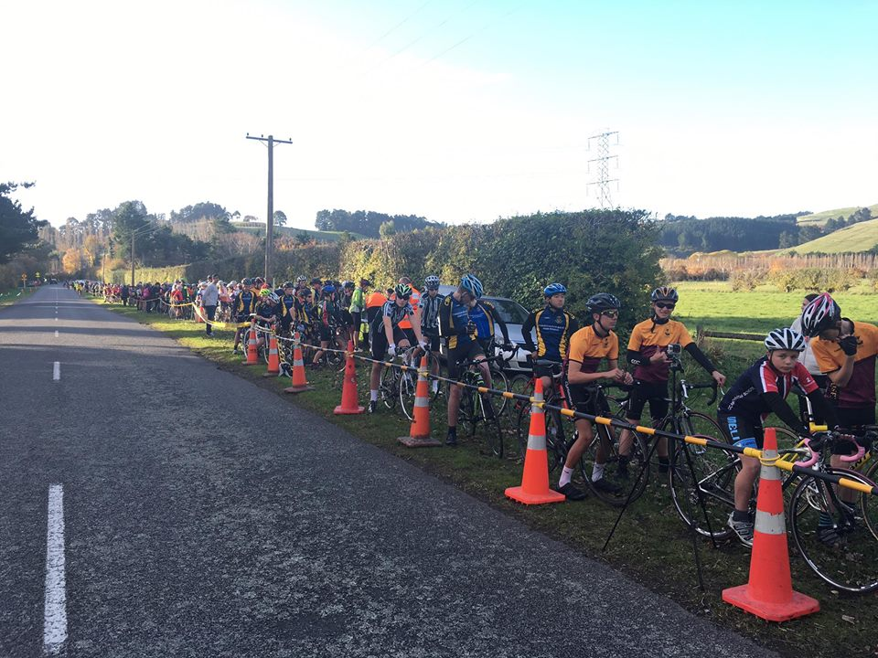

Contents
A Document Control/Contact/Location
1. Introduction .......................................................................................................................
2. Events Overview..................................................................................................................
3. Key Event Roles and Contacts............................................................................................
3. Rules
6 Racing Dates
6 Course Maps ......................................................................................................................
7 Safety Commitment...........................................................................................................
8 Event Insurance.................................................................................................................
9. Media Management and Policy.........................................................................................
10. Information to Participants................................................................................................
11. Information to the Public .................................................................................................
12. Accident/ Incident Reporting..........................................................................................
13. Traffic Management ........................................................................................................
14. Waste Management ........................................................................................................
15. Lost and Found.................................................................................................................
16. Vehicle Support................................................................................................................
17. Event Staff Training..........................................................................................................
18. Event Headquarters/Communications Centre ................................................................
19. First Aid ............................................................................................................................
20. Event Timing and Participant Identification ....................................................................
21. Contingency Planning ......................................................................................................
22. Emergency Planning and Response .................................................................................
23. Risk Management ............................................................................................................
24. Glossary……………. ............................................................................................................
Appendix 1 Event Insurance
Appendix 2 Entry Event Terms& conditions
Appendix 3 NZSCA Racing Rules
Appendix 4 Cycling New Zealand Road & Track Technical Regulations
Appendix 5 Copy of Safety Briefing Notes
Appendix 6 Copy of Letter to Residents
Appendix 7 Serious Accident and Incident Form (Notifiable Incident)
Appendix 8 Minor Accident and Incident Form (Non-Notifiable Incident)
Appendix 9 First Aid Treatment Summary
Appendix 10 Traffic Management Plan
Appendix 11 Radio Protocol
Appendix 12 Event Improvement Form
Appendix 13 Event Database
Appendix 14 Key Contacts
Appendix 15 Contingency Plan
Appendix 16 Emergency Planning
Appendix 17 Emergency Response
Appendix 18 Risk Management Register

A Document Control/Contact/Location
Document Control and Review
Policy Title | Health and Safety Policy & Plan
Policy Review Number: | Version 05
Effective Date: | 1 May 2021
Review Period: | This Health & Safety Policy & Plan will be reviewed annually
Policy Audience: | All Workers and Contractors
Responsible Role: | Kevin Searle

Contact and Responsibility see Section 3 for full contact list & Associated PCBUs
Key Personnel | Designation/Responsibility | Mobile Number

1. Introduction
The purpose of this document is to provide a framework to assist the event staff in delivering a safe environment for all those involved in the event. This includes a process to evolve and improve the manual as new risk emerge as well as improving measures to address existing risks.
The document will be reviewed on site and will be updated accordingly. It will also be reviewed annually to ensure it is up to date.
The scope of the environment referred to as 'The Event' and or 'Work Place' is dynamic and varied. It includes the field of play and event venues and other areas as specified and includes task such as setting up, delivery of key functions, pack down and any other tasks as specified.
The term 'Event Staff refers to any persons involved in assisting or setting up the event or as specified.
This document is intended to provide a practical approach to identifying and dealing with Accidents and Incidents that may arise during the event. It also outlines details to assist event staff to undertake their duties in a safe manner to avoid, minimize or isolate identified risks. Because of the nature of the event delivery, not all scenarios can necessarily be identified; therefore this document includes procedures to assist event staff to safely deal with these if they arise, these include contingency plans
and emergency planning.

2. OVERVIEW- SCHOOL CYCLING PROGRAMME OF EVENTS 2019
These events, known as the Christchurch Schools Cycling Racing Programme. The events are managed by a local organising committee on behalf of Cycling New Zealand Road and Track Canterbury.
These events are held between May and September each year in the Christchurch area.
The events have the approval of Christchurch city Council and Selwyn District Council
Venue: Old Tai Tapu Road - Halswell
1.5 km from Akaroa Highway, just past Rossendale Wines
Race Day: Wednesdays
Start Time: 3.20pm. Sharp. [Registrations from 2.40pm.]
Cancellations: Sports Director makes decisions regarding cancellations.
The decision may be to issue a cancellation notice by 1 0.00am or put decision on hold till no later than 12 noon Schools are advised by Fax message and notice on Schools Web Site - www.canterbury.schoolsport.org.nz/ cancellations
Cancellation will also be posted on our Facebook page: https://web.facebook.com/christchurchschoolscycling/
3. KEY EVENT ROLES & CONTACTS
Committee chairman Kevin Searle
Race Manager Brian Thompson
STMS & Site Director Noel Curtis
Volunteer Manager Brian Thompson
Race HQ Manager Leanne Creighton
Communication Manager Kevin Searle/Hamish Ferguson
Chief Commissaire Hamish Ferguson
Timing Manager Hamish Ferguson
Health and Safety Officer Kevin Searle
Disputes & Discipline Kevin Searle, Hamish Ferguson, Brian Thompson (ANY 2)
Schools Liaison Gary McNaughton
First Aid advised weekly
Emergency Response 111
Christchurch Police 111

3. RULES
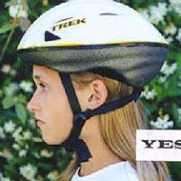
The following are specific rules used weekly .
Race Numbers: Sign on and collect number on arrival
Wear on left side of shorts
Return Immediately you finish
Helmets: Must be worn correctly at all times. This includes to and from racing.
Accessories: Sports cameras and headphones are not permitted while racing.
Cycles: Must be safe and roadworthy
Lights: Shorter days going into winter means you must have lights to go home safely.
Uniform: We adopt a reasonably flexible approach to uniform particularly novices and students at schools without significant cycling organisation.
If your school has a racing uniform it is compulsory for you to wear it. This is non-negotiable!
Individual sponsors have no place in school cycling. If your team has a sponsor then that sponsorship should be contained on the leg panel/and /or top of your uniform as per schools rules.
As per the school rules warmup jackets can have any sponsorship but must not be used in the race.
Riders who do not have a school race shirt should wear a plain colour preferably one of the colours from your school. In the past some schools have worn a school basketball shirt over a plain cycling shirt. For riders in this category please do your best to comply on Wednesdays.
Similarly plain shorts must be worn. Most have a discrete logo and this is acceptable but trade shorts and significant logos are unacceptable.
For full details see https://schools.cyclingnewzealand.nz/assets/Cycling-New-Zealand-Schools-Rules-1-January-2021.pdf
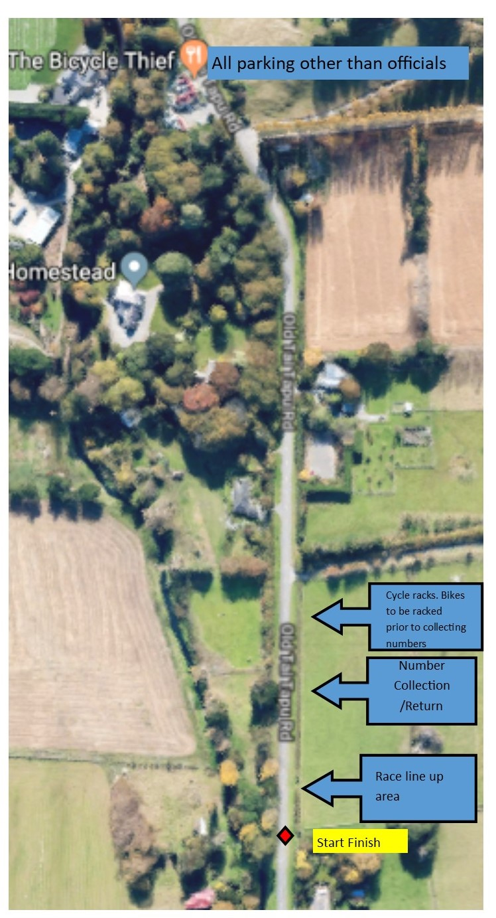
Parking: Our biggest issue has become the management of supporters' vehicles. As we are required to manage the area parking will be in accordance with the attached plan. All supporter parking must be in The Bicycle Thief Restaurant Car park. We are very fortunate that the Bicycle Thief restaurant has generously made this area available to us.
This is also the area that drop-off of cyclists must take place. Here is to be no drop-off of cyclists in the plan area.
If supporters choose to ignore our officials our only recourse will be to penalise their riders.
Start/Finish Area: All cyclists must keep off the roadway before starting races and after finishing races. All cyclists must keep their cycles well off the road on the start side of the roadway. Do not gather on the road side of vehicles
Toilets
We have a toilet in the driveway by the start zone.
NOTE: The Bicycle Thief is a restaurant and we need to respect that. No one who is involved with School Cycling is to use the toilets there or seek to fill water bottles at the restaurant. Please respect their request as the use of their car park is essential for the safety of the event

Neighbours: We expect courtesy to residents of neighbouring properties!
We have plenty of marked spectator area.. Do not use neighbours driveways!
When we get a complaint it is usually because a neighbours tolerance has run out.

Littering : this is a no no and riders can expect penalties if caught littering. Similarly parents caught littering can expect school points deducted from their child’s school.
We and neighbours are not there to clean up your rubbish!!!!

Behaviour
Every official is a volunteer and without them this event would not happen. Courtesy towards officials is expected. Cyclists swearing within hearing of Commissaires should be aware that disqualification may follow.
First Aid
While first aid is primarily the responsibility of each school we would ask that any suitably qualified first aiders make themselves available to assist.

Gearing for all Christchurch Schools events
A&B grades Maximum gear is 7.00 metre travel.
C & below grades Maximum gear is 6.610 metre travel
[Travel is one complete revolution of pedal]
Regular Pre-race gear checks will be conducted and random after race checks throughout the season
Points Competition
Each race day riders earn points for themselves and their School towards end of season trophies. Scratch Races: 10 points - 1st., 8 points - 2nd., 6 points - 3rd., 4 points - 4th.,2 points - 5th. - each race. Plus I point for start.
Time Trials: Top 25 Boys & Top 25 Girls. Points 25 down to I - plus I Point for start
Teams Races: - Points only accumulate for the Christchurch Schools -5 Race Scotty Browns Team Time trial series. 5 points - 1st., 3 points - 2nd.,2 points - 3rd., 1 point - 4th.
Seeding
The aim of your cycling should be to improve. This season when a rider wins 2 races or has 3 placings in their grade then that rider will be promoted up a grade. When a rider is promoted the lowest performing rider in that promotion grade will be relegated to the grade below.
Christchurch Schools Cycling Team Time trial series.
-Open to all schools and school riders in Canterbury
-The competition will compose Year 7/8 under 16 and under 20 grades for boys and girls.
-The Time Trial Series will compose four events. The winners will be decided on the total of the 4 events. In the event of a tie the winner will be decided on count back.
-The winners will receive the Canterbury Schools Team Time Trial series trophies
-Race dates are as per the Christchurch schools cycling calendar.
Team composition
-School and Composite Teams of 4 with time recorded on fastest three finishers.
The series:
The series will be held in parallel with the Canterbury team time trial championships and South Island Schools Championships.
School teams Individual schools can enter Teams e.g. Team A, Team B and Team C. Teams within a school may change riders through that series but it will be the nominated team which receives series points e.g. Christchurch Boys High A may have different riders for selection during the season but it will be the team A which receives the points each time teamA races.

Composite teams
A school which genuinely cannot field a team of four in each grade may combine with another school. Once a composite team is nominated that team will compete in the series. A composite team may have a reserve and may use a non-nominated reserve when nominated riders are unable to compete to enable the team to compete.

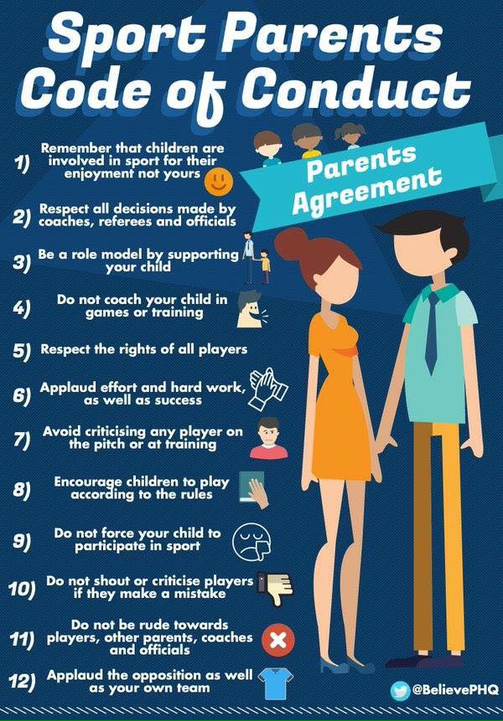
Racing
Cycling is a non-contact sport. There is no contact permitted. This also extends to negative tactics like blocking at the front. If your Schoolmate is out in front you don't have to chase but it is against the rules to sit at the head of the race and try and slow the group.
Please take care when using brakes. Using brakes at the front of the group is unsafe!!!
Negative racing. We can't enforce this but racing hard on Wednesdays is your best preparation.
Crossing the centre line-Intentional crossing of the centre line while racing will result in disqualification. Without limiting the decisions of Commissaires making progress on the wrong side of the road amounts to intentional crossing

Parents- we expect you to follow this code:

To all riders: these events are held on public roads open to normal traffic at all times. You must obey the Road code at all times keeping as far to the left as possible.

In all respects race organisers will have the final say over racing matters having regard to these rules and the rules of Cycling New Zealand Schools and then New Zealand Road and Track Technical Regulations.

4. Racing Dates 2021
May
12 Registration Day
19 Individual Time Trial - 8 km
26 Graded Scratch -l2km&8km

June

02 Graded Scratch -l2km&8km

09 Graded Scratch -12 km & 8 km
16 4 Person Teams Time Trial - (Scotty Browns Teams Series Round 1)
23 Hill Climb Time Trial - 2.3 km (Kennedys Bush Road)
30 Graded Scratch -l2km & 8km

July
07 Individual Time Trial - 8 km
10 [Saturday]
Cycling New Zealand Schools South Island Road Championships (subject to a separate Health & Safety Plan)
Mike Pero Raceway Christchurch
Races all age groups Boys & Girls. (Time Trials & Teams Races)
Also Scotty Browns Teams Series (Round 3)
11 [Sunday]
Mike Pero Raceway Christchurch
Races all age groups boys & girls. [Scratch Races]
14 & 21 July – NO RACING-TERM BREAK
July
28 Graded Scratch - 12 km & 8 km
31 4 Person Teams Time Trial - (Scotty Browns Teams Series Round 3)
August
07 Graded Scratch - 12 km & 8 km
14 Canterbury Schools Teams Championships -15 km. [Teams of 4] Litolff - Dawe - Searle & Webb Cups - Tai Tapu Hotel 2.00 pm Start
(Also Scotty Browns Teams Series Round 4)
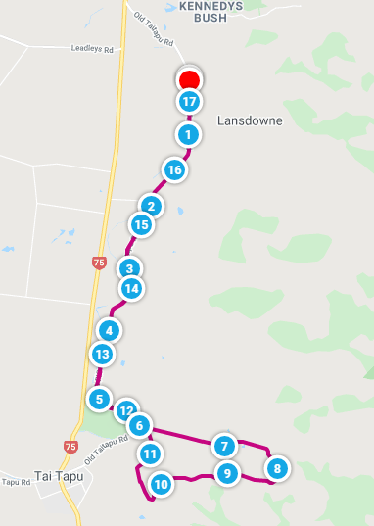
21 Graded Scratch - 12 km & 8 km
28 Graded Scratch - 8 km and *NEW EVENT FOR 12 KM GRADES Gravel and Tar event17 km https://www.mapmyride.com/routes/view/4234568212

September
04 Individual Time Trial - 8 km
End of Season Prize Giving following race. Venue to be advised.
19 SUNDAY – 1 day event with TTT and Road race… Venue to be advised.

5. RACE BRIEFING
There are race briefings which are held at the start of each day's race.
The main purpose of the race briefing is to raise the participant's awareness to the potential hazards of the event course.
The race briefing will cover the following
• Brief description of the day's event
• Roads not closed to other traffic
• Must keep to left side of road
• No support traffic
• Participants may be disqualified or given a time penalty if seen breaching the rules
• Specific safety information for that day

6. MAPS
See Appendix 19

7. SAFETY COMMITMENT
The organisers are committed to providing and maintaining utmost health and safety standards, by ensuring that all risks and hazards associated with the event are adequately identified managed or mitigated to prevent harm from occurring to the event staff, participants and all other personnel involved.
8. EVENT INSURANCE
The events have Liability Cover Insurance Policy in place through Membership of Cycling New Zealand. The Liability package includes six different liability insurance products;
• Public Liability (General Liability)
• Associations Liability
• Statutory Liability
• Professional Indemnity
• Employers Liability and
• Legal Prosecution Defence Costs
See Appendix 1

9. MEDIA MANAGEMENT & POLICY
Any media attending the event should report to the Events Manager immediately on arrival to the event. Media shall be advised that no unauthorized vehicles are permitted on course and that no quotes or comments are to be sought from any non-authorised persons.
Nobody connected with the event is authorised to speak to the media without the express permission of the Race Manager, Chairman of Cycling New Zealand Road &Track Canterbury or the Chairman of Cycling New Zealand Schools.
Event Staff and Volunteers are notified of this policy during their briefing. Any unauthorized release of photographs or statements is forbidden.
In the event of a major incident, the Emergency Response Plan will be initiated and any comment will be made by authorized personnel once an appropriate response has been formed following the review of all relevant information.
INFORMATION TO PARTICIPANTS
The following summarises information received and available to participants.
A. Entry Information
Events entry is available to Schools and authorised students. The following information is required:
• First Name, Surname, Gender, DOB of each participant
• Teacher in Charge
• Team Manager
• Contact person on the day
• Agreement to the Events Terms& conditions (See Appendix 2)
• Any medical conditions from any student taking part
An overview of the briefing will also be read to the competitors prior to each race. Briefing Notes can be found in Appendix S. These are guidelines only subject to Para 5 above.
INFORMATION TO THE PUBLIC
With this being school events with young inexperienced participants and the fact that the road is not closed it is essential that the public are aware that the events are taking place.
The following initiatives are taken to maximise public awareness that there are regular school cycling events taking place between May and September. This not only takes part on the days of the events but leading up to the events.
The aim of this exposure is to try and encourage as many drivers as possible from being on the course during the event.
1. Letters dropped into neighbours letterboxes See Appendix 6.
2. Social Media Posts from Christchurch Schools Cycling and other local stakeholders

EVENTS SOCIAL MEDIA
OTHER EMAIL COMMUNICATIONS
Regular emails are sent to SCHOOLS containing a number of safety and information messages in relation to racing. These include the following:
• Importance of getting bike and other gear checked
• Support traffic not tolerated
• Information about safe riding in a bunch
• Sportsmanship
• Restricted Parking

12. ACCIDENT INCIDENT REPORTING
Any minor incidents will be covered through business as usual Health and Safety procedures. Under the Health and Safety at Work Act 2015 (HSWA) law the event is required to report any Notifiable events to Work Safe NZ.
Any Notifiable Events are to be reported to the Race Manager and they will ensure the appropriate reporting is completed. (See Appendix 7)
Any non-notifiable events are to be reported to the Race Manager as soon as practicable by phone/radio. They are then required to complete the relevant forms given to them (See Appendix 8) after the event. These will be reviewed logged in the Event Risk Management Register. (See Appendix 18).
A notifiable event is when any of the following occurs as a result of work:
a death
notifiable illness or injury
a notifiable incident.
All Incidents and accidents are to be recorded in Event Risk Management Register. This is then reviewed for the following year as part of our continuous safety improvement process
School representatives will also be asked at the race briefing to inform the event of any accidents or incidents that happen to them during the event.
Schools and/ event first aider asked to submit a list of people treated on the course and a description of what they have been treated for and what happened (See Appendix 9)
13. TRAFFIC MANAGEMENT
The Traffic Management Plans for events are approved by Christchurch City Council and Selwyn District Council. The plan will be implemented by the Events organising committee. Copies of the traffic management plans are available for inspection at the events and upon request.

14. WASTE MANAGEMENT
The events acknowledge that the nature of the events will produce additional waste. Schools are asked to manage their own waste and remove from the events.
15. LOST & FOUND
The organisers recognize that there is a risk of children/vulnerable persons becoming lost or separated from their caregivers. A process to react to any situations is outlined in the Emergency Response Plan (See Appendix 16)
16. VEHICLE SUPPORT
The events have vehicle support organised including the following:
- Cycling New Zealand Commissaire and floating vehicles
The duties of the above groups are as follows:
- Vehicles- Public Awareness
- Commissaires- Responsible for managing and monitoring the rules and conduct of the participants for the events (includes motorcycle commissaires)
- Safety Vehicle- ensure all cyclists have returned and course closed

17. EVENT STAFF TRAINING
Event staff will be briefed prior to undertaking any duties. At the briefing the organisers provide an will overview of the event and then go through each position in detail and will be advised of any specific risks controls required to protect themselves and other. It will also cover Radio Protocol if required (See Appendix 11).
Event Staff are given the opportunity to ask questions.
Event staff are also allocated accident/incident report forms, key contacts, emergency procedures, provided with a Fluro vest and details on their roles.
An Event Improvement Form (See Appendix 12) will be handed out during the racing season to each staff member at the briefing for the opportunity of giving feedback of each position to enable organisers to look at areas that need improving or addressing at season debriefing held after the events.

18 EVENT HEADQUARTERS
The events will have a Race headquarters operating each day. The role of the headquarters is as follows:
• To provide a base for general event enquires
• To provide a base for Lost and Found (persons and equipment)
• To coordinate communications and support around emergencies
The headquarters will hold a copy of the Event Master Database (See Appendix 13), Key Contact numbers (See Appendix 14) and Lost and Found Forms (See Appendix 17)
19. FIRST AID
To participate in these events the school representatives are asked at the time of entry to disclose any illness or medical concerns that may affect the riders’ performance or be relevant if medical treatment is required. This information will assist medical personnel to administer appropriate treatment should this become necessary during the events.
The School representatives also accept the terms and conditions in recognition of the risk around competing in a cycling event agrees that their riders are fully capable of participating in the even without causing harm to themselves or others, that the riders have sufficiently trained for participation in these events and have not been advised otherwise by a qualified medical person.
The obligation of Medical support for the events is with each participating School. The events will provide a first aid kit at the event and will endeavour to have a volunteer first aider available.
Local Medical Centres and Emergencies Services are easily contactable from the events.
See Emergency Planning (Appendix 16) for more.

20. EVENT TIMING & PARTICIPANT IDENTIFICATION
Timing for the events is done manually.
In addition to the timing, participants are issued with race numbers that are required to be attached to their race jerseys.
Team Time Trial —All team members are issued with the team same number. To be worn on the centre back of each participant.
Individual Races - All riders are issued with a unique race number to be worn on the left side of the participant as directed.
21. CONTINGENCY PLANNING
The events recognise that there is the potential for circumstances outside of their control occurring that could result in the published event format and/or distance being adjusted in the interest of participant and officials’ safety.
If inclement conditions exist, all decision regarding the implementation of the contingency plan will be made by the Contingency Committee.
See Appendix 15.
22. EMERGENCY PLANNING AND RESPONSE
The event recognises that there is the potential emergency situations to occur. The events have considered likely scenarios and have developed examples of appropriate response should they should occur. It is recognised that an incident can occur at any time and that not all those responding will have access to the Planning and Responses procedures.
See Appendix 16
See Appendix 17
23. RISK MANAGEMENT
The event has produced a Risk Management Register. The purpose of this document is to outline the Events approach to risk management. It outlines the means of identifying known risk associated with the event and records any accident or incidents that occur at the event.
See Appendix 18.

24. Glossary

Accident
An unplanned and undesired event that results in injury to people or damage to property
Briefing
A verbal or written account of the Event to participants. It will include a safety briefing which will point out risks to the participants.
Competent
A person, able (through knowledge, training and/or experience) and willing, to perform an assigned task
Competitor/Participant
A person who takes part in the Event
Contingency Plan
An alternative plan devised for a specific situation.
Commissaire
The Chief Commissaire is responsible for the fairness of the event and the application of the rules.
Emergency
Any notifiable event or situation concerning the health, injury, death, missing person, or extensive damage involving staff, participants or property.
Escalation Point
The person who is referred to for assistance, leadership or decisions by a particular Event Staff or needs to be advised in the event of a specific situation (i.e. a Serious accident).
Event
All the activities and specific races that make up the full event schedule, including the set up and pack down operations that ensure that the scheduled races can occur.
Event Manager
This role is varied; it can be as extensive as being responsible for the entire Event from planning through to event delivery and the debrief process to simply planning, overseeing of the event and debrief.
Event Staff / Event Team
All those working on or at the Event. This does not include contractors who will come under their own companies’ Health and Safety Manual. Tri NZ company H&S policy includes checking contractors’ policies are acceptable to Tri NZ.
Event Venue
Every building, land, park and water area utilized by Event Staff and Participants during the operations of the event. The Event Venue may at any given time include or exclude certain parts as necessary, for example the registration area may be closed after registration has ceased. The event Venue does not include the Field of Play
Hazard Register
Also known as ‘Risk Register’ or ‘Risk Identification Schedule’
Where a Risk is identified and managed appropriately (eliminated, or minimized)
Incident
An unplanned and undesired event which, under slightly different circumstances, could have resulted in an accident
Injury
Harm or damage to a person
Marshal
A person who is responsible for maintaining the flow of the event, keeping control of spectators and traffic, or maintaining security. They will be a minimum of 18 years of age if located on a road.
Marshal Management Plan
A document which identifies the numbers and locations of marshals to be assigned to an event along with the duties of the marshals assigned to these various locations. The plan should also record the names and contact numbers of the marshals assigned.
Mandatory
It is a legislative duty, it must happen.
Medical Team
A team of professional medical personnel that can include a Doctor, St Johns/Paramedics and other people with specific training to deal with injuries likely to occur during the event and with training that enables them to assist and stabilize injured persons. Ideally this would include the ability to transport injured persons, if needed, to the nearest hospital.
Notifiable Event
Under the Health and Safety at Work Act 2015 (HSWA) you must notify WorkSafe NZ when certain work-related events occur. A notifiable event is when any of the following occurs as a result of work:
- A Death (immediately call WorkSafe NZ 0800 030 040)
- Notifiable illness or injury
- A notifiable incident
Policy
The general principals or intentions of agreed behaviour in a particular situation
Procedure
How the organization implements the policy
Race HQ
A control centre should be established at each event that functions as a central point for communication, decision making and
Risk
An occurrence, situation or substance that could occur to cause harm or injury to person or loss or damage to property during the preparation for, running of, and pack-down of an event.
Risk Management
A process of identifying and managing risks in order to prevent an accident, incident or loss
Rules
The rules that apply to all at this event.
Run Sheet
A timeline of key activities that need to occur in order to ensure that the Event is delivered on time and that serves to remind people about key activities and the timing of these.
Safe
In relation to a person, means not exposed to any Risks; and in every other case, means free from Risks, “unsafe” and “safely” have corresponding meanings.
Security Team
Event Staff that are specifically assigned to ensure that security is maintained as needed throughout the delivery of the event, this may include overnight security or security for finish areas.
STMS
Site Traffic Management Supervisor and at the appropriate level for the volume and Level of roads at the Event
Tail End Charlie
An assigned Event Staff member, who is responsible for travelling along the course behind the last participant in order to ascertain that all participants have either completed the course or withdrawn and are no longer on the course or in need of assistance.
Team Leader
A member of the Event Staff that oversees Event Staff and in some cases event delivery of certain portions of an Event
TMP
Traffic Management Plan
Workers
Event staff for the event and volunteers

Appendix1- INSURANCE policy now current to 12/19
Certificate of Currency
To Whom It May Concern

This certificate hereby certifies that cover has been granted subject to the exceptions, terms and conditions and definitions of the Policy (as amended
from time to time, including after the date of this Certificate of Currency). Details of Insurance
Issuing Office: | New Zealand
Insured: | Cycling New Zealand including affiliated organisations, technical personnel, accredited coaches and development personnel, event personnel, administrators, directors and volunteers whilst performing activities for and on behalf of Cycling New Zealand and all affiliated  organisation activities and event
Class: | Public & Products Liability
Policy Period: | From: | 31 December 2018 at 4.00pm
 | To: | 31 December2019at 4.00pm
Policy Territory: | Worldwide
Policy Number: | NZCASA03264
Limit of Liability: | NZ$5,000,000 any one Occurrence and in the aggregate in respect of the  Products Hazard
Policy Benefits: |  |  | Sub-Limit
 | New Zealand Exemplary Damages |  | NZ$2,000,000
 | Care, Custody & Control |  | NZ$500,000
 | Forest & Rural Fires Act |  | NZ$2,000,000
 | Vibration and Removal of Support |  | NZ$500,000
 | Service & Repair – Machinery,  Vehicles, Watercraft |  | NZ$250,000
 | Underground Services |  | NZ$250,000
 | Product Recall Expenses |  | NZ$100,000
 | Excess Motor Liability |  | NZ$5,000,000
 | Business Advice / Services /  Medical Persons |  | NZ$5,000,000
 | Mechanical Plant |  | NZ$5,000,000
 | Indemnity to Principals and others |  | NZ$5,000,000
 | Advertising Injury |  | NZ$5,000,000
 | Vendors Indemnity as additional  Insured’s |  | NZ$5,000,000
 | Tenants Liability |  | NZ$5,000,000
 | USA/Canada – exports |  | NZ$5,000,000
 | Sudden & Accidental Pollution |  | NZ$5,000,000

Please refer to your agent, broker or the relevant Chubb office for further information or a copy of the Policy. Chubb Insurance New Zealand Limited has an “AA-” insurer financial strength rating given by Standard & Poor’s (Australia) Pty Limited. Signed at Auckland on behalf of Chubb Insurance New Zealand Limited.
Signed at Auckland on behalf of the following Insurers:

 | 13 January 2017
Authorised Representative  Chubb Insurance New Zealand Limited | Date of Issue

Chubb Insurance New Zealand Limited. Company Number: 104656 FSP Number: 35924 Chubb®, its logos, and Chubb.Insured.SM are protected trademarks of Chubb.
www.chubb.com/nz.

Appendix2For participation in: 2021 Christchurch Schools Road Cycling Programme including related programmes and/or activities (“Event”)
PLEASE READ THESE TERMS AND CONDITIONS CAREFULLY BEFORE CONTINUING WITH YOUR ENTRY AND/OR SIGNING. THIS FORM HAS LEGAL CONSEQUENCES AND WILL AFFECT YOUR LEGAL RIGHTS AND WILL LIMIT OR ELIMINATE YOUR ABILITY TO BRING FUTURE LEGAL ACTIONS.
NOTE Entry of School teams to events will amount to acceptance of these terms
A. INTRODUCTION I understand and acknowledge that by agreeing to this Terms and Conditions Form (“Form”), that I am legally agreeing to the statements in this Form on behalf of my school, our students and attending support officials, that I have the authority to do so and that these statements are being accepted and relied upon by the Released Parties, as defined below. Please note that the Event social media pages may contain other terms and conditions that apply to the Event. By participating in the Event I also acknowledge my acceptance of the terms and conditions set out on the Event social media pages. If another person has submitted my registration for the Event, I understand that person is assumed to be my agent and that person has accepted on my behalf all the terms and conditions set out on this Form, the Event website social media pages.In consideration of being permitted by Cycling New Zealand (on behalf of Cycling New Zealand Schools) or delegated persons (hereafter “ORGANISER”) to participate in the Event, I acknowledge and agree as follows:
B. ACKNOWLEDGEMENT AND ASSUMPTION OF RISKS The Event and other activities associated with the Event take place indoors or outdoors in various locations and can include, but are not limited to: warm-up exercises; competitive and recreational cycling, both in practice and in the Event; demo-ing (trying out) gear; participation in clinics, training, demonstrations or other games and activities, attendance at any activities and travelling in planes, vans, buses or other vehicles to and from activities (the Event and other activities collectively referred to in this Form as “activities”). Activities may be scheduled or unscheduled, mandatory or optional, structured or unstructured and include free time. I acknowledge that the inherent and other risks, hazards and dangers (collectively referred to in this Form as “risks”) of these activities can cause injury, damage, death or other loss to participant or others. These risks include but are not limited to those associated with: any competitive, recreational or athletic activity; the need for extreme fitness and endurance; an outdoor or indoor environment; the decision making and conduct of ORGANISER’s staff members, officials, volunteers, contractors, co-participants or others; cycling or other activities; the participant’s personal health and participation, whether participant’s health conditions are disclosed or undisclosed, known or unknown; locations or premises; equipment; and the conduct of co-participants, spectators and/or other third parties.

I understand and agree:
1. I will review all materials received, accurately complete and agree to the registration information, documents and process, and obey all rules, regulations and policies at all times. These rules, regulations and policies include, but are not limited to, the rules and conditions detailed in this Form and as detailed on the Event website, www.schoolscycling.nz, Drug Free Sport NZ, Cycling Anti-Doping Foundation Authority (CADF) Regulations, the competitive and administrative rules of Cycling New Zealand, Cycling New Zealand Schools and Union Cyclist International (UCI), as may be amended, and all traffic laws. Failure to comply in any way with these matters may lead to me being pulled from the Event, disqualified and banned from future participation in Cycling New Zealand and Cycling New Zealand Schools events.
2. My final acceptance and participation in the Event is contingent upon ORGANISER’s receipt and review of all required information and forms, including this Form;
3. I am fully capable of participating in the Event without causing harm to myself or others. I further agree that I am physically fit, have sufficiently trained for participation in this Event and I have not been advised otherwise by a qualified medical person.
4. To respect the rights, dignity and worth of every individual at the Event including participants, volunteers and spectators. I will at all times act professionally and responsibly and maintain high standards in respect to my language and actions and will not discriminate against any person on any grounds but in particular based on sex, sexual orientation, ethnicity, religion, ability or performance;
5. Before participating in any activities, I may inspect the race course, facilities, equipment, and areas to be used, if I choose. I will immediately advise ORGANISER or an Event official if I believe or become aware that the race course, facilities, equipment or areas to be used in the Event are unsafe.
6. The information provided in this Form is not exhaustive, other unknown or unanticipated activities, inherent or other risks and outcomes may exist, and ORGANISER cannot assure my safety or eliminate all risks. ORGANISER representatives are available should I have further questions about the activities or the associated risks;
7. I am voluntarily participating with knowledge of the risks. Therefore, I assume and accept full responsibility for myself, for the inherent and other risks (both known and unknown) of the activities, and for any injury, damage, death or other loss I may suffer, resulting from those inherent and other risks, including but not limited to the risk of my, a co-participant’s, a Released Party’s, a spectator’s, a volunteer and/or a third party’s passive or active negligence or other misconduct.

C. RELEASE AND INDEMNITY
PLEASE READ CAREFULLY. THIS RELEASE AND INDEMNITY SECTION CONTAINS A SURRENDER OF CERTAIN LEGAL RIGHTS. In consideration of the acceptance of my entry, I hereby take action for myself, my executors, administrators, heirs, next of kin, successors and assigns as follows:
1. I HEREBY WAIVE, RELEASE AND DISCHARGE Cycling New Zealand, Cycling New Zealand Schools, Event sponsors, Event organizers, Event promoters, Event producers, race directors, Event officials (Commissaires), Event staff, advertisers, administrators, contractors, vendors, volunteers, district Councils or local bodies of whatever nature in which the Event may be staged, New Zealand Police, NZTA, and all property owners and provincial, city, town, county, and other governmental bodies, and/or municipal agencies whose property and/or personnel are used and/or in any way assist in locations where the activities take place, and each of their respective parent, subsidiary and affiliated companies, assignees, licensees, owners, officers, directors, trustees, partners, board members, shareholders, members, supervisors, insurers, agents, employees, volunteers, contractors and representatives and all other persons or entities associated or involved with the activities (individually and collectively referred to in this Form as the "Released Party" and the “Released Parties”) with respect to any and all claims, liabilities, suits or expenses (including attorneys’ fees and costs) (collectively referred to in this Form as “claim” or “claim/s”’) for any injury, damage, death, lost and/or stolen property or other loss in any way connected with my enrolment or participation in the activities, negligence, whether passive or active, of the Released Parties, any breach by the Released Parties of statutory duty, and/or use of any equipment, facilities or premises, howsoever caused. I AGREE HERE TO WAIVE ALL CLAIM/S I MAY HAVE AGAINST THE RELEASED PARTIES AND AGREE THAT NEITHER I, NOR MY ESTATE, HEIRS, ASSIGNS OR BENEFICIARIES NOR ANYONE ELSE ACTING ON MY BEHALF, WILL MAKE A CLAIM AGAINST THE RELEASED PARTIES FOR ANY INJURY, DAMAGE, DEATH OR OTHER LOSS I MAY SUFFER.
2. I HEREBY INDEMNIFY AND HOLD HARMLESS (“indemnify” meaning protect by reimbursement or payment) the Released Parties with respect to any and all claim/s brought by or on behalf of me, my spouse, a family member, a co-participant or any other person, for any injury, damage, death or other loss in any way connected with my enrolment or participation in the activities, negligence, whether passive or active, of the Released Parties, any breach by the Released Parties of statutory duty and/or use of any equipment, facilities or premises, howsoever caused.
3. THIS RELEASE AND INDEMNITY SECTION INCLUDES BUT IS NOT LIMITED TO CLAIM/S FOR PERSONAL INJURY OR WRONGFUL DEATH (INCLUDING CLAIM/S RELATED TO EMERGENCY, MEDICAL, DRUG AND/OR HEALTH ISSUES, RESPONSE, ASSESSMENT OR TREATMENT), PROPERTY DAMAGE, LOSS OF CONSORTIUM, BREACH OF CONTRACT OR ANY OTHER CLAIM, INCLUDING CLAIM/S RESULTING FROM THE NEGLIGENCE OF THE RELEASED PARTIES, WHETHER PASSIVE OR ACTIVE.
D. OTHER PROVISIONS
I understand and agree:
1. If I am signing as the participant’s legal guardian or authorised School signatory, I have the legal authority to act for the participant and on their behalf. If my guardian status is challenged or found invalid, I will defend and indemnify the Released Parties, to the fullest extent allowed by law and per the provisions of this Form, just as if I were the participant’s lawful legal guardian.
2. The Race Packs (which may contain athlete’s race bib and timing chip) must be picked-up by either the registered athlete in person or the Team Manager (if applicable) at the scheduled registration for the Event, as detailed on the Event website. I hereby acknowledge that the School must have a Cycling New Zealand Schools to pick-up race packs. Failure to do so may be result in riders being unable to participate at the event.
3. I authorise ORGANISER staff, representatives, contractors or other medical personnel to obtain or provide medical care for me, to transport me to a medical facility, and to provide treatment (including but not limited to evacuation, hospitalisation, blood transfusions, surgery and medications) they consider necessary for my health. I agree to pay all costs associated with that care and transportation. I agree, to the release (to or by ORGANISER, insurance carriers, other health care providers and their staff, representatives or contractors) of any medical information or records necessary for treatment, referral, billing or other purposes. I agree to provide the name and contact phone number of a person, who is not a participant in the Event, who can be contacted in the event of an emergency, which person will be available during and after the Event.
4. I grant to ORGANISER, its affiliates, designees and assignees the right and permission to photograph, film, record and/or otherwise capture in any media the name, image, voice, written statement, photograph and/or visual likeness of me and/or my family members (collectively “images”), with right to sublicense, during the activities or otherwise, without compensation, for use for any purpose in any media throughout the world in perpetuity, including but not limited to use in broadcasts, photographs, publications, podcasts, webcasts, motion pictures, brochures, CDs, DVDs, internet websites, social media platforms, television, and/or in any related commercial, informational, educational, advertising, or promotional materials. I understand that all ownership and copyright rights in the images shall be owned by ORGANISER and I waive any inspection or approval rights. I understand and agree that my name, bib number and race results will be available to the public during and after the Event.
5. I consent to Cycling New Zealand Schools, Cycling New Zealand or the organiser providing my personal details to the authorised event photographer which may contact me via email to alert me when photos from the Event are available on its website.
6. I consent to my name and contact details being included on Cycling New Zealand and the ORGANISER Event database and that unless I specify to the contrary, I will be subscribed to various Cycling New Zealand and ORGANISER related publications which include a monthly newsletter and other promotional materials about upcoming events. I acknowledge that I am able to opt-out of these services at any time. I agree that if I choose not to be included on the Cycling New Zealand or ORGANISER’S Event database I will still receive newsletters that relate to the Event in which I have registered. I also agree that it is my responsibility to obtain information and Event up dates from the Event website (if applicable).
7. I am fully responsible for the security of my personal possessions at the Event and ORGANISER will not be liable for the replacement of any personal possessions.
8. Cycling New Zealand, Cycling New Zealand Schools and the ORGANISER reserves the right, in its sole discretion, to dismiss any participant from the activities, to deny or revoke entry of any applicant at any time, to issue special entries and/or to disqualify any participant from the Event. If I am dismissed or depart for any reason, I agree that I am responsible for all costs of early departure whether for medical reasons, dismissal, personal emergencies or otherwise. If my Event entry application is denied or revoked, I agree that ORGANISER is not responsible for costs incurred or damages suffered by me or my family in excess of the amount of the entry fee. In the event that ORGANISER denies or disqualifies any participant from the Event (either before or during the Event), ORGANISER will not refund any entry fees to that participant where the participant has misrepresented their eligibility to participate in the Event at the time of entry or has breached any of the conditions of this Form.
9. Cycling New Zealand, Cycling New Zealand Schools or the Organiser, in its sole discretion, may delay, modify, or cancel the Event, including the right to alter the advertised course or start time (at their absolute discretion). If the Event is delayed, modified, or cancelled, including but not limited to acts of God or the elements (including without limitation, wind, rough water, rain, hail, hurricane, tornado, earthquake), acts of terrorism, fire, threatened or actual strike, labor difficulty, work stoppage, insurrection, war, public disaster, flood, unavoidable casualty, race course conditions, or any other cause beyond the control of ORGANISER, there shall be no refund of the Event’s entry fee or any other costs incurred in connection with the Event.
10. This Form is effective in regard to participant’s enrolment or participation in the activities from the date signed and /or entry into races through the completion of all activities, and this Form shall remain in full force and effect following completion of all activities.
11. Cycling New Zealand may assign this Form to other entity/s or individual/s (“assignees”) at any time, and any such assignment will grant assignees the full rights and protections accorded in this Form.
12. If I wish to withdraw from the Event, I must do so myself and the event specific cancellation policy set out on the event website will apply.

13. My Event registration is not transferable to other people or other events. Any attempt to transfer my entry or allow another person to participate under my name may result in cancellation without refund, insurance being deemed as void and disqualification from participating in future Cycling New Zealand. Cycling New Zealand Schools and the Organiser’s events.

………………………………………………………………….
School and Principal’s Name

………………………………………………………………….
School Principal’s Signature

Appendix 3 Maps
Hill Climb

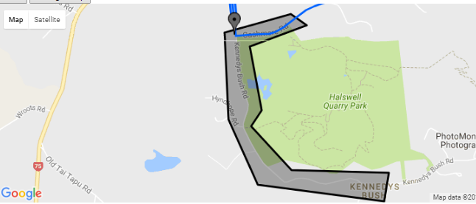

Weekly Race

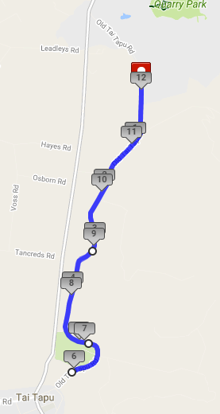

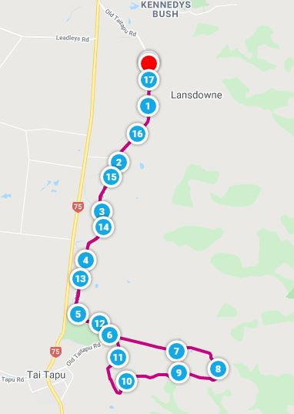
Gravel and Tar Event

Appendix 3 -NZSCA Racing Rules
Appendix 4 -Cycling New Zealand Road & Track Technical Regulations
Refer: https://schools.cyclingnewzealand.nz/rules-and-regulations/

Appendix 5
Commissaire - Road Race Briefing Notes
Christchurch Schools Road Cycling programme
• Today's race is km.
You will be riding on OPEN ROADS therefore you must comply with the NZ Traffic Regulations at all times and the race rules of Cycling New Zealand Road & Track and the NZSCA.
• The course will be marshalled and signposted but, the ultimate responsibility is with you to ride safely and be aware of other traffic
• YOU MUST KEEP LEFT AT ALL TIMES AND DO NOT CROSS THE CENTRE LINE
• Other races will be on the course at the same time, do not become involved in these
• There is to be no touching or contact between riders and no pushing or assistance is to be given by parents, teachers or coaches
• Keep both hands on the handlebars at all times no cable holding
• For scratch races This race will be a neutralized start to the indicated start for scratch races
• For scratch races- When advised The first five finishers must report for gear check immediately after crossing the finish line. Failure to do so could result in disqualification
• Have a safe race, ride to win and good luck
Accidents- cyclists and Marshalls
• In an event of an accident/crash, help the competitor from the course or if serious divert other cyclists around the site ensuring their safety at all times.
• If you have access to a a cell-phone contact - the Race Manager
• If the accident is serious then the individual should not be moved, call 111 immediately and then contact Kevin
Marshalls
Please note the following general information.
1. All roads are open to the public.
2. Please wear the Hi-vis Safety vest done up at all times, on the outside of all Clothing, including raincoats.
3. Remember to keep yourself safe at all times. Cars and cyclists need to be able to clearly see you. Please face any on coming vehicles (don't turn side on).
4. Participants will be relying on you to maintain a safe course so please familiarise yourself with your position and be vocal in your directions. If you have any questions around your role please ask.
6. Report any minor accidents or problems to and fill out your accident form and hand back to the Race Manager
Whip Briefing Sheet - Teams Time Trial /Time tral
• Check number
• Team/ rider order
• Have 5 teams/10 riders ready to go
• Riders are wearing an approved safety helmet • Check bar ends are plugged
• Wheels must have minimum 16 spokes • Rims no greater depth than 45mm
• No carbon or composite rims, spokes
• No disc or fixed wheels
• Standard handlebars
• Brief riders -
Obey instructions of all officials
If overtaken, keep left & avoid all contact with the overtaking team
It is forbidden to draft off your opponents who are less than 25m ahead If overtaking teams shall pass on a parallel of not less than 1.5 metres Dropped riders may finish but not draft, interfere or assist another team
• Brief hold procedure

Whip Briefing Notes Road Race
Commissaires Check -
• Riders have correctly placed number/s
• Check two race numbers are on - 1 centre back or 1 on riders left side • Riders are wearing an approved safety helmet
• Check uniforms comply with Schools Rules
• Handlebars are standard no aeros
• Check bars ends are plugged
• Wheels must have minimum 16 spokes
• Rims no greater depth than 45mm
• No carbon or composite rims, spokes
• No disc or fixed wheels
Commissaires To Brief
• Race commences with a neutral start until all riders have a fair start. The lead car will then pull away
• Do no overtake the lead car if present during the neutral phase
• Those riders dropped well behind the main race may be withdrawn
• Please obey all instructions of the race officials

2021
Dear Householder
Christchurch Schools Cycling is holding Schools Road Cycling each Wednesday in your area from Early May to Mid-September. This is the long running cycling competition for schools in Christchurch. The success that our Olympians and Commonwealth riders enjoy starts on this road.
Our Management area will be on the straight after Bicycle Thief Restaurant. Set up will begin at 1.30pm, with racing starting at 3.20pm and finishing by5.00pm. Cyclists will race from the straight after Bicycle Thief Restaurant on an out and back circuit. The turnaround is near Taitapu domain. We have traffic management in place throughout the course and and mobile race supervisors following riders.
We reiterate to cyclists that they must obey the road rules and keep to the left-hand side of the road, but we do ask that you take care when coming out of your driveway between the above-mentioned times. We have tried to cover every householder in your area with our letter drop but please, if you are talking to your neighbour, ask if they are aware of our event.
We have strict rules around parking and littering.
We would like to thank residents for their patience during the season. Your support and assistance enables us to create future Olympians.
Thank you for your understanding.
Yours sincerely
Brian Thompson
Race Manager
Cycling New Zealand Schools Christchurch

Appendix 7
NOTIFICATION OF A DEATH OR A NOTIFIABLE INJURY OR ILLNESS
Use this form to notify WorkSafe New Zealand of a notifiable event ie an injury, illness or death to a person(s), as required by section 56 of the Health and Safety at Work Act 2015 (the Act)
Did you know you can save time by completing this form online, click here

Notifier details
Are you making this notification as a:
(See the last page of this form for descriptions of these terms)
PCBU
Other
Title:
Last name:
First name:
Middle names:
Phone number:
Mobile number:
Postal address:
Town/city:
Postcode:
Email:
Details of event
Date of event:
(dd/mm/yyyy)
Time of event:
(e.g. 2:20pm)
Event address:
Town/city:
Postcode:
Provide a description of what happened:
Confirm that the site has been preserved, as required by section 55 of the Act:
Have you notified any other agency?
Yes
No
Notified agency name:

Notified agency phone number:

Injury Details:

Have multiple people been injured?
Yes (complete and attach one copy of this page per person) No
Nature of Injury
Select all applicable (If the event you are attempting to notify us of does not appear in this list, then notification is not required and this form cannot be used):
Death
Amputation of any body part
Serious head injury

Serious burn
Serious eye injury
Separation of skin from underlying tissue (scalping or degloving)
Spinal injury

Serious lacerations
Injury or illness that requires (or would usually require) medical treatment within 48 hours of exposure to a substance
Loss of bodily functions
Injury or illness that requires (or would usually require) immediate hospital admittance

Serious infection (incl occupational zoonosis)
Other injury or illness declared notifiable by regulations
Body part(s) affected

Select all applicable:
Head Neck Trunk

Upper limb Lower limb Systemic internal organs
Injury description

Briefly describe the injury:

I have attached any supporting information (photographs or diagrams).
Treatment attempted:
Not known
First aid only
Doctor (not hospital)
Hospitalisation
(supporting information is not mandatory, but should be supplied when helpful in explaining the incident)

Injured/Ill person detail
Family/surname:
Date of birth:
Given names:
Gender:
Residential address:
Town/city:
Injured person's phone number: Affected person type:
Contractor (self-employed)
Postcode:
Worker
Other
How many hours had the person been at work when the incident occurred:
PCBU Details
Legal entity name:
(the name that is used on official legal documents)

Trading name:
(if different to legal name)

New Zealand Business Number (NZBN):
(if applicable)

Industry:
Accommodation and Food Services
Administrative and Support Services
Agriculture
Arts and Recreation Services
Construction
Education and Training
Electricity, Gas, Water and Waste Services
Financial and Insurance Services
Health Care and Social Assistance
Fishing
Forestry
Information Media and Telecommunications
Manufacturing
Mining – Minerals
Mining – Petroleum
Mining – Other Services
Not Elsewhere Included
Other services (specify below)
Professional, Scientific and Technical Services

Retail Trade
Public Administration and Safety
Transport, Postal and Warehousing
Rental, Hiring and Real Estate Services
Wholesale Trade

Specify other:
Physical address:
Town/city:
Postcode:

Postal address
Same as above
Postal address:
Town/city:
Postcode:
PCBU phone number:
PCBU mobile number:
PCBU contact:
(first name, last name)

Email:

Is the PCBU investigating?
Yes
No
Health and Safety Representative (HSR) details
There is an HSR working for this organisation They are NZQA qualified to use their powers
Where to send your completed form

Print, complete and scan this form, or fill in the PDF version. Once completed, email it to WorkSafe:
healthsafety.notification@worksafe.govt.nz

If emailing this form is not practical, you may post it to:
The Registrar WorkSafe New Zealand PO Box 105-146
Auckland 1143

Terms
PCBU — A PCBU is a ‘person conducting a business or undertaking’. A PCBU may be an individual person or an organisation. It does not include workers or officers of PCBUs, volunteer associations with no employees, or home occupiers that employ or engage a tradesperson to carry out residential work. A PCBU must ensure, so far as is reasonably practicable, the health and safety of workers, and that other persons are not put at risk by its work. This is called the ‘primary duty of care’.
Worker — A worker is an individual who carries out work in any capacity for a PCBU. It includes an employee, a contractor or sub-contractor, an apprentice or trainee, a person on work experience or a work trial, or a volunteer worker. Workers have their own health and safety duty to take reasonable care to keep themselves and others healthy and safe when carrying out work.
Declaration
Full name: Date:
(first name, last name)

Designation:
Note: the above declaration is considered to be an electronic signature that is reliable as appropriate for the purpose of this notification
I declare that to the best of my knowledge, the information provided in this notification is true and correct.

Appendix8 Hazard Identification and Control Form
If you have identified a Hazard in the workplace, please complete this form and hand to the Health and Safety Representative for actioning. If you are unsure or do not wish to deal with the hazard yourself, approach your Health and Safety Representative, explain and they will assist you in dealing with the Hazard.

Name:________________________________ Date of hazard:_______________________
I believe that there is a hazard in our place of work located at:
This hazard is:
I suggest the following controls to mitigate the hazard:
ELIMINATE – MINIMISE (circle one)
Risk rating before controls: | Risk Rating after controls:
Likelihood: 1 = unlikely, 5 = highly likely
Potential Harm 1 = band aid or minor, 5 = major or death
Combine numbers to get rating

ACTION TAKEN BY WHOM: DATE: / /
Describe how the Hazard was Remedied:
Added to Hazard Register by Whom: DATE: / /
Review Completed by Whom: DATE: / /
Further Controls Required: YES / NO (if yes please state)
Any further details (witnesses etc)

Appendix 9 Event First Aid Treatment
Date Venue/Location
First Aid Volunteer first aid certificate Yes/No
Sign on
Sign off
No. | Time | Injury/Condition | Event/Cause/Mechanics | Treater | Treatment | Parent  notification

Appendix 10
Traffic Management Plan … see attached PDFs
Available for inspection at race venues.

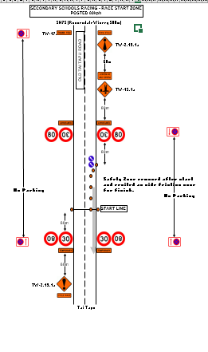
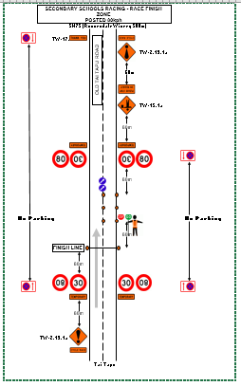
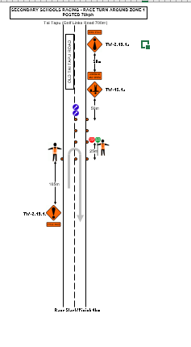
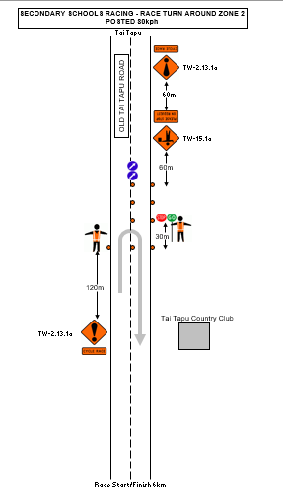

Appendix 11 Radio Protocol

Key staff may be issued with a two-way radio. It is the individual’s responsibility to ensure they have been briefed sufficient on the correct use as all radios do not operate the same.
There is a process to using a radio and it is preferred that you use the following 6-steps which is defined below.

General Radio Protocol:
- Think about what you are going to say – before you do
- Listen for the airways to be clear before beginning
- Press and hold the Talk button
- Breath / Pause
- Speak slowing and clearly
- Say who are you wanting to speak to first and who you are
- Release the button and await response
- Once you have completed your message, finish with the words ‘Over”/Copy to signal you have finished conversation

Example Conversation:
Race Manager is wanting to speak to Chief Commissaire
RM: “Chief, Chief this is Race Manager, over”
Chief: “This is Chief receiving, over”
RM: “Rider #43 is withdrawing from the event, over”
Chief: “Confirming rider #43 is withdrawing from the event, over”
RM: “That is correct, out”
Note for emergency communication use the word “PRIORITY” before commencing your message
Example Priority Call:
“Priority, Priority, this is Chief, we require medical assistance at the finish line”
If you hear this message stay off the airways until situation is back under control
In an emergency dial 111
In the event of sensitive information, it is best practice to use Cell phone.

EVENT IMPROVEMENT FORM
Appendix12 Event Improvement form

Event: ___________________________________________________________

Role/Position: _____________________________________________

Can you recommend any improvements for this event?

Did you have any issues? How would you recommend that we can improve this issue?

Do you have other feedback or comments about the event?

Name ………………………………………………………………………………………………………………………..

Mobile…………………………………………………………. Email……………………………………………………..

Appendix 13- Event database
To be completed at close of season registration

Appendix 14
Key Contacts
Event Coordinator Kevin Searle 0272238669
Race Manager Brian Thomson 021756621
STMS & Site Manager Noel Curtis 0276607183
Volunteer Manager Brian Thomson 021756621
Communication Manager Kevin Searle/Hamish Ferguson
Chief Commissaire Hamish Ferguson 0272211533
Timing Manager Hamish Ferguson 0272211533
Season Points Manager Bruce Dawe 027643 3346
Health and Safety Officer Noel Curtis 0276607183
Disputes & Discipline Kevin Searle, Hamish Ferguson, Brian Thompson
First Aid 0n site VOLUNTEER
Emergency Response 111
Christchurch Police 111

Appendix15- Contingency Planning
The event recognises that there is the potential for circumstances outside of their control occurring that could result in the published event format and/or distance being adjusted in the interest of participant and officials’ safety.
If inclement or adverse conditions exist, all decision regarding the implementation of the contingency plan will be made by the Contingency Committee. When decisions are reviewed, considerations must be made to the level of risk and what is accepted conditions that can occur in events of this nature.
The Contingency Committee will consist of:
The Event Coordinator
The Race Manager
The Site Manager/STMS
The Chief Commissaire
The Race Manager will monitor weather contingencies and will call together the Contingency Committee if inclement conditions exist or a significant change in the event plan has occurred.
In the unlikely event the Event is required to be cancelled or postponed a decision should be made 11.30am on race day if possible.
The Event Coordinator will inform participants via appropriate means (including the MC, social media, and website and in person)
The Race Manager shall inform course staff
The Chief Commissaire shall inform Commissaires.
Other Key staff shall inform those under their direction.
The Race Manager is the only person authorised to speak to the media or make any public comment.

Appendix16- Emergency Planning

Emergencies that may occur during the Event have been considered and appropriate plans developed to manage these.

Simple and easy to follow flow charts have been created to best facilitate the management of the identified emergencies. These are located in the following pages.

Debrief incident

Ensure safety of yourself and all others in the vicinity.
Check for potential hazards and secure the area.
Once the area is secured assess whether any injury or harm has occurred.
Yes
No
Assess injury and attend if assistance is required
Take any actions possible to reduce risk of hazard occurring again.
Does the person require any further medical assistance?
Yes
No
Secure your safety and the patient’s safety and the safety of those around the scene.
Call Event Medical Team
If no response call 111
Can the person complete the event?
Yes
No
Carefully observe and monitor the person's condition where possible.

Report to Race Manager

Transport person to assistance by whatever means suitable.

Report to Race Manager

2 SERIOUS HARM INCIDENT (Notifiable Incident)

Report to Race Manager

Race Manager to Report to Event Coordinator

Debrief incident
Event Coordinator to
Notify Work safe and follow procedures outlined
Amend Safety Plan where appropriate
Event to Arrange Critical incident stress debrief where appropriate
Assign Site Controller
Event Coordinator to implement ‘Emergency Response Plan’
Report to Race Manager
Do not comment to any other parties

Race Manager to Report to Event Coordinator

Ensure safety of yourself and all others in the vicinity.
Check for potential hazards and secure the area.
Once the area is secured assess whether any minor injury or harm has occurred.
Yes
No
Assess injury and attend if assistance is required
Take any actions possible to reduce risk of hazard occurring again.
Does the person require any further medical assistance?
Yes
No
Secure your safety and the patient’s safety and the safety of those around the scene.
Call Event Medical Team
or
If no response call Race Manager

Is the person able to continue in role?
Yes
No
Carefully observe and monitor the person's condition where possible.

Report to Race Manager

Transport person to assistance by whatever means suitable.

Report to RaceManger

1 Minor / Moderate Incident on the course (Non Notifiable Incident on Course)
NON NOTIFIABLE INCIDENT
Report to Race Manager

Does the patient require transportation to the hospital or are they or First Aid requesting
‘School Contact’ to be notified
No
Yes
Race Manager to call ‘School Contact’

3.Competitor Fatality

If a death occurs, the Race Manager to call the Police on 111

Follow instructions from Emergency Services

Race Manager to work with Emergency Services

Race Manager to advise Race Coordinator, Chairman Schools Cycling, Cycling New Zealand CEO and implement ‘Emergency Response Plan’

The police will contact the family. No Event Staff should not make the first contact with the family

Key Event staff to be quietly informed of the fatality by the Race Manager. No one else is to be informed.

Appointed Spokesperson to handle any media and public comments after the event. NO other staff to comment.

Debrief the processes after the event and alter safety plan where appropriate

Arrange Critical incident stress debrief where appropriate

4 Missing Competitor or Adult

Once a report of a missing person is received complete Missing Persons Form and Notify Race Manager
Race Manager initiates missing person process:
- Completes forms
- Phone call to missing Competitors school contact
- Radio to other event staff
- Race Manager initiates a sweep of all other logical areas.
If search is unsuccessful the Race Manager notifies the Police (refer Contacts section)

Race Manager liaises with police and act on their instructions
Debrief incident
Race Manager Arrange Critical incident stress debrief where appropriate
Amend Safety Plan where appropriate

5 Missing Persons (Adult OR Competitor) Report Form

Date: | Time:
Report written by:
Information about missing person
Name
Address
Age
Phone number
Last know point
Description of Missing Person
Gender
Ethnicity
Clothing description
Unique physical features
Information about Party reporting missing person
Name
Address
Phone Number
ID Viewed and Checked
Complete when missing person is found
Location person was found
Who found person
Date: | Time:
6 Missing LOST Child (non competitor) / Vulnerable Person

(MCVP)
Once a report of a MCVP person is received complete LOST MCVP form
Notify Event Director
027 644 8921
Event Director to advise all radio users and commentary team on Lost MCVP details
Debrief incident
Complete form
Call Emergency Services and follow instructions
Amend Safety Plan where appropriate
Assign nominated staff as a liaison for school/family
MCVP found within 30 minutes
Yes
No
Debrief incident
Amend Safety Plan where appropriate
Event Director to liaise with Services

7 MCVP REPORT FORM  Date: | Time:
Report written by:
Information about missing Child/ Vulnerable Person Lost
Name
Address
Age
Vulnerable Comment
Phone number
Last know point
Description of missing Child/ Vulnerable Person
Gender
Height/Weight
Ethnicity
Clothing description
Unique physical features
Information about Party reporting missing Child/ Vulnerable Person
Name
Address
Phone Number
Relationship with missing child/person
ID Viewed and Checked
Complete when missing Child/ Vulnerable Person is found
Location missing child/Vulnerable person was found
Who found child/person
Released into the care of: Name/Relationship/ID
Notify Event Staff/Emergency Services (if applicable)
Date: | Time:

8 FOUND Child / Vulnerable Person
FOUND CHILD/VULNERABLE PERSON (FCVP)
As soon as a FCVP is identified complete FOUND FCVP form
Notify Event Director
027 644 8921
Event Director to advise all radio users and commentary team on FCVP details
Debrief incident
Complete form
Call Emergency Services and follow instructions
Amend Safety Plan where appropriate
Assign nominated staff as guardian of FCVP
Parent/Guardian found within 30 minutes
Yes
No
Debrief incident
Amend Safety Plan where appropriate

9 FOUND Child / Vulnerable Person - Report Form (FCVP)

Date: | Time:
Report written by:
Information about found Child/ Vulnerable Person Found
Name
Address
Age
Vulnerable Comment
Phone number
Last know point
Description of found Child/ Vulnerable Person Found
Gender
Height/Weight
Ethnicity
Clothing description
Unique physical features
Assign Staff Member as Guardian
Name
Address
Phone Number
ID Viewed and Checked
Complete when parent/guardian or Caregiver is FOUND
Name of Parent/Guardian
Relationship to Child/Vulnerable person
Address
Phone Number
ID Viewed and Checked
Notify Event Comms/Emergency Services (if applicable)
Date: | Time:

10 Fire Plan

FIRE

IF YOU DISCOVER A FIRE

R
Remove - people from immediate danger.

A
Alert – contact emergency services, dial 111.

C
Confine the fire – if possible.

E
Extinguish – if considered safe to do so.

General points: -

- Pay attention to escape routes from the area. Often the way in is the only way out.

- Account for all those in the area, and remove from immediate danger. Assembly point individual to each location.

- If unable to evacuate, is there a place that is safe to go to? i.e. a bunker.

- If the fire is small try to contain by removing, where possible, any further sources of fuel for the fire to feed on, and eliminate where appropriate with a water source.

- Only attempt to extinguish the fire if it is safe to do so, and use the appropriate extinguishing method for the appropriate fire.

- If an electrical fire, turn the power supply off before trying to extinguish.

All event personnel should know site name, location, and know whom to contact in an emergency

Appendix 17

Emergency Response

This plan is written to assist the process in the likely event of a serious, critical, life threating or fatal incident (Notifiable Incident)

Key Notes:

- Ensure Emergency services have been dispatched
- Race Manager to initiate Emergency Reponses Checklist once incident has been advised
- The Race Manger will be dispatched to oversee and manage the scene immediately
- Keep yourself and those around you safe while making the scene as safe as possible
- No staff, officials, volunteers or others are authorised to speak to the media unless authorised by the Race Manager
- The Race Manager is the only person authorised to speak to school contacts/event coordinator
- In the unlikely event of death, the police are the only person authorised to speak to the school contacts/race manager/next of kin.

See Checklist Over:

Emergency Response CHECKLIST

Priority | Task | Key Staff | Time | Comment
1 | Incident call received
2 | Dispatch Emergency Services
3 | Dispatch Race Manager
4 | Event Coordinator notified
5 | Advise Police if Notifiable
6 | Advise School Contact
7 | Assign School Liaison
8 | Advise Key Staff, Chairman of CNZS and CNZ CEO
9 | Receive Update from scene
10 | Collect any belongings from scene
11 | Complete Notifiable Incident Report
12 | Collect Witness Details

Appendix 18- Risk Management Register

1. Risk Management

Effective Risk Management applies a clear process to identify risks, sets an acceptable level for risk and takes steps to keep risks at that level. Risks are managed by assessing potential consequence and likelihood of occurrence and working out a clear action and response plan.

The Event, so far as is reasonably practicable, must ensure the health and safety of its workers and that other people are not put at risk by its work.

1.1 Risk Identification Policy

It is the events policy to identify risks in the event. Identified risks are then assessed for the likelihood of consequences (risk), managed and then monitored.

1.2 New Risks

Any new risk identified at any time prior to or at the event should be reported to the Race Manager who will make a note of it, direct any control and review it as part of the post event debrief process.

Volunteers, officials and event staff may need to make quick decisions regarding risks and take quick actions to manage and avoid escalation of the situation. Where possible the Race Manager should be notified to authorise these changes. In some cases event personal may have to use common sense to deal with a given situation.

These instructions form part of event personal briefing.

1.3 Review Process

After the event a review is conducted to ensure that risk controls in place were effective and to review any new risks identified. Key Staff are involved in this process.

Key Staff are provided with an Event Improvement Form to record any further feedback.

1.3 Risk Categories

Risk categories for this event can be defined as:

Strategic: Strategic risks can be defined as key matters at business board level and/or Central Government level that have a potential impact on the whole business, rather than just the event.

Operational: Operational risk can be defined as the risk resulting from inadequate or failed procedures, systems or policies in the planning and or delivery of the event. Includes Health and Safety.

Reputational: Reputational risk can be defined as any potential actions that will affect the character or standing of the business or event. This can includes any actions from direct and in-direct association with external organisations.

Financial: Financial risk can be defined as exposure to the event suffering any degree of un-planned financial loss.

1.4 Consequence of Risk

High

Strategic: Considered major risk to the business strategic plans which may affect the future stability or direction of the business. Potential advisory required to central government.

Operational: Considered major risk to the delivery of the event that could result in the cancellation or major alteration to the programme or event planning. Includes any major health and safety incident that results in a fatality or serious harm.

Reputational: Considered major risk to reputation of the event or the business that is considered irreparable. Includes actions of direct and in direct stakeholders.

Financial: Above $10,000

Moderate

Strategic: Considered moderate risk to the business strategic plans which may have some impact or moderate effect on the direction of the business.

Operational: Considered moderate risk to the delivery of the event that could result in the delay or moderate alteration to the programme or event planning. Includes any moderate health and safety incident that results in a moderate injury or harm.

Reputational: Considered moderate risk to reputation of the event or the business that needs a dedicated communication and media plan to minimise and isolate. Includes actions of direct and in direct stakeholders.

Financial: Up to $5,000

Low

Strategic: Considered low risk to the business strategic plans which may have little or no impact on the direction of the business.

Operational: Considered low risk to the delivery of the event that could result in minor delay or alteration to the programme or event planning. Includes any minor health and safety incident that results in a minor injury or harm.

Reputational: Considered low risk to reputation of the event or the business that is easily mitigated by existing communication and media plans. Includes actions of direct and in direct stakeholders.

Financial: Up to $1,000

1.5 Likelihood of Hazard

Highly Likely

75 - 100% likelihood that it will occur

Circumstances are highly likely to arise often

Expected frequent/regular occurrences

Likely

35 - 74% likelihood that it will occur

An above average chance that this risk will occur

Likely to occur more than once, but not an ‘every day’ occurrence

Possible

0 - 34% likelihood that it will occur

A remote or small chance of occurrence

Likely to occur at least one, but not expected to occur much more than this

1.6 Determining Risk Level

Risk level is determined by multiplying the CONSEQUENCE and LIKELIHOOD.

LIKELIHOOD | Highly Likely (3)
 | Likely (2)
 | Possible (1)
 |  |  | Low (1) |  |  | Moderate (2) | High (3)
KEY: |  |  |  |  | CONSEQUENCE

Low Risk (1-2) | Moderate Risk (3-4) | High Risk (6) | Extreme Risk (9)

1.7 Escalation of Risk

There is an agreed process to follow once Risks Levels have been identified.

Low Risk Awareness by the Race Manager

Moderate Risk Raised by Race Manager to Event Coordinator

High Risk Raised by Event Coordinator to Contingency Committee

Extreme Risk Raised by Contingency Committee to Cycling New Zealand Schools Executive Representative

1.8 Risk Register

Risk ID | RISK CATEGORY | RISK | CONSEQUENCE  3 – High  2 – Mod  1 - Low | LIKELIHOOD  3 – Highly Likely  2 – Likely  1 - Possible | OVERALL  RISK RATING  2019 | CONTROLS | RESPONBIITY | MINIMISED/  ELIMINATED
1 | Operational | Adverse weather on the event day creating a safety hazard and disruption to the event. | 3 | 2 | 6 | Monitor Met Service website.  Provide a weather update at Team and Official meetings  Schools to provide shelter for competitors.  Event to provide shelter for officials  Provide instruction to event participants about safe riding techniques in adverse weather conditions.  Ensure Contingency plans are in place. | Event Manager | Minimise
2 | Operational | High or gusting winds causing damage to equipment/structures, injury or disrupting event. | 2 | 2 | 4 | Monitor Met Service website.  Ensure all contractors are fulfilling their own H&S requirements.  Schools communicate to ensure they bring and use sufficient equipment.  All event infrastructure correctly weighted or dismantled if insufficient weighting is available. | Site Manager  Schools | Minimise
3 | Operational | Excessive heat leads to heat stress and heat illness | 3 | 1 | 3 | Monitor Met Service website.  Ensure a water supply is available for participants.  Schools to provide shelter for competitors.  Event to provide shelter for officials  Ensure Contingency plans are in place. | Race Manager  Site Manager  Schools | Minimise
4 | Operational | Poor visibility creating a safety risk for participants and event personnel (e.g. fog, poor light) | 2 | 2 | 4 | Event conducted during daylight hours.  Event personnel to wear fluorescent vests while on road.  All support vehicles to have headlights on.  Provide instruction to event participants about safe riding techniques in poor visibility conditions.  Ensure Contingency plans are in place. | Race Manager | Minimise
5 | Operational | Extreme weather creating a safety risk and causing a disruption to the event | 3 | 2 | 6 | Monitor Met Service website.  Ensure Contingency plans are in place. | Race Manager | Minimise
6 | Operational | Damage to land or property resulting in damage to reputation, legal implications, financial impact or injury | 2 | 1 | 3 | Appoint a site manager.  Conduct site inspection and identify any potential hazards in risk assessment prior to pack in.  Ensure Contract is in place for venue use.  Ensure Contractors and venue provide H&S Register.  Brief Contractors as they come on site.  Fence off vulnerable areas where possible.  Choose hard surfaces for parking areas where possible.  Minimise onsite parking and provide Park and Ride options.  Ensure adequate insurance is in place. | Site Manager | Minimise
7 | Operational | Inadequate waste management resulting in damage to reputation and/or injury | 1 | 1 | 1 | Schools requested to ensure designated areas are kept clean  Riders reminded on littering rules  Course and site inspections conducted before vacating event site | Site Manager  Race Manager  Schools | Eliminate
8 | Operational | Excessive noise resulting in public complaint and/or damage to reputation | 1 | 2 | 2 | Notification of event provided to local residents  PA communication restricted to necessary only communication before 7am and no later than 7pm | Site Manager | Minimise
9 | Operational | Event Personnel being hit by vehicles during setting up and dismantling of event infrastructure | 3 | 2 | 6 | Event Personnel to wear fluorescent vests during all set up and pack down  Ensure adequate Traffic Management provision for significantly set up and pack down periods. | Race Manager  Site Manager  STMS | Minimise
10 | Operational | Vehicles and event participants conflicting in car parking areas or at start and finish locations | 2 | 1 | 2 | Parking plan developed for start and finish areas to minimize potential conflict between event vehicles and riders before and after the event  No parking zones implemented and communicated to participants. | Site Manager  Race Manager | Minimise
11 | Operational | Public vehicles and event participants conflict on course resulting in injury to participants | 3 | 2 | 6 | Traffic Management Plan (TMP) prepared by STMS. Approved and signed off by Council  Traffic controlled on the event course by accredited traffic controllers or marshals in accordance with the TMP  Letters sent to local residents  Stop/go Marshalls provide a warning to approaching traffic and protection for riders  Provide briefing and instruction to event participants on safe racing requirements | Race Manager  Chief Commissaire  STMS | Minimise
12 | Operational | Official Event support vehicles conflicting with participants resulting in injury | 3 | 1 | 3 | Official Event support vehicles under the direction of the Commissaire via Mobile phone  All drivers are briefed prior to the event.  Schools advised that no personnel rider support vehicles permitted on the course. | Chief Commissaire  Schools  Race Manager | Minimise
13 | Operational | Support vehicles conflicting with other vehicles or members of the public | 3 | 1 | 3 | Official Event support vehicles under the direction of the Commissaire via Mobile phone.  Support vehicles required to drive with headlights on.  Vehicles are to apply caution when approaching ‘blind’ corners and to choose safe sections of road and alert riders when overtaking.  Vehicles are required to adhere to road rules unless under the direction of the Police.  All drivers are briefed prior to the event. | Chief Commissaire  Schools  Race Manager | Minimise
14 | Operational | Event participants injuring themselves by falling off their bicycles or crashing into each other | 3 | 3 | 9 | Entries/Riders are endorsed by schools.  Schools agreeing to event waiver.  Riders’ responsibility to be familiar with the rules of racing available on event website.  Provide briefing and instruction to event participants about safe riding techniques.  Ensure finishing straight is of an appropriate width and length in the likelihood of a bunch sprint.  First Aiders on site and contactable and accessible throughout the event.  Emergency Response Plan in place | Race Manager | Minimise
15 | Operational | Event Participants crashing as a result of hazards or obstacles on the course | 3 | 2 | 6 | Course inspection to identify all hazards and obstacles and minimize where possible (e.g. sweep debris, indicate potholes etc.).  Provide briefing to riders on potential hazards and obstacles  If warranted, race can be neutralised through areas of potential hazard. | Race Manager  Chief Commissaire  STMS | Minimise
16 | Operational | Participants crashing as a result of equipment failure e.g. puncture; breakages to spokes, chain, stem, handlebars etc. | 3 | 2 | 6 | Rider Information and/or event website advises participants that it is their responsibility to ensure that their bike is kept in good working order. | Schools | Minimise
17 | Operational | Grade or group of participants is too large for the course / venue increasing the risk of crashes | 2 | 1 | 2 | Reduce or limit participant numbers per grade or group as appropriate for the event course. | Race Manager | Eliminate
18 | Operational | Skill, age or fitness level of participants too low for the course or conditions causing participant to be a risk to themselves or others | 3 | 2 | 6 | Minimum age is applied.  Participants ride within set age groups.  Event only receives entries from Schools  Provide briefing to riders on safe riding practices in relation to course conditions.  If conditions warrant it, modify the course (subject to modifications meeting permit conditions) or delay, postpone or cancel the event. | Event Manager  Race Manager  Chief Commissaire | Minimise
19 | Operational | Participants not complying with race rules or marshal instructions resulting in accident, injury, damage to reputation, financial and/or legal implications | 3 | 2 | 6 | Riders responsibility to be familiar with the rules of racing  Riders are distinguished by a racing number.  Race rules detailed on FB Page  Pre-race briefing details race rules and conditions.  Non-compliant competitors face warning, disqualification and/or fine issued by race officials.  Racing stopped in cases of ongoing offenders. | Race Manager  Chief Commissaire | Minimise
20 | Operational | Support vehicles not complying with event rules and requirements resulting in accident, injury, damage to reputation, financial and/or legal implications | 3 | 1 | 3 | No personnel support vehicles permitted to follow the race.  Riders associated with offending vehicles can face warning, disqualification and/or fine issued by race officials. | Race Manager  Chief Commissaire | Minimise
21 | Operational | Unexpected adverse traffic conditions (which may vary during the event) pose a safety risk to participants | 2 | 1 | 2 | Chief Commissaire and Race Manager able to be contacted by mobile phone.  Low use roads have been selected for courses.  Letters send to local residents on course.  Consult with traffic management provider if any changes are appropriate.  If conditions warrant it, delay, alter, postpone or cancel the event. | Race Manager  Chief Commissaire | Minimise
22 | Operational | Grades or categories of riders merge, overlap or overtake each other causing riders to crash or conflict with vehicles | 2 | 1 | 2 | Apply a time gap between grades or categories to minimise risk of groups overlapping.  Chief Commissaire and Race Manager able to be contacted by radio and/or mobile phone.  Limit group sizes in accordance with the nature of the course  Should the situation of merging grades or categories occur, plan to neutralize the slower moving group until the faster group has passed. | Race Manager  Chief Commissaire | Minimise
23 | Operational | Participant going the wrong way on the course or venue causing risk to others or risk of getting lost | 2 | 1 | 2 | Event course made available to all participants pre-race.  Provide pre-race briefing and directional signage and/or marshals to be appointed to areas of potential ambiguity. | Race Manager | Minimise
24 | Operational | Participants are left stranded on the course | 2 | 1 | 2 | All riders are briefed to report to an official if they abandon the event.  Ensure that the driver of the sweep vehicle (if available) is briefed on remaining behind the last rider in the race and they pick up any participants (or advise of their location) who are unable to complete the event.  Additional vehicles available to transport stranded riders. | Race Manager  Chief Commissaire  Timing Manager | Minimise
25 | Operational | Volunteers are left stranded on the course | 2 | 1 | 2 | Volunteers provided with transport to and from remote sites.  Sweep Vehicle to drive course and advise marshals that last rider has passed their station.  Volunteers required to check in with Volunteer Manager when returned from event duty. | Race Manger Manager | Minimise
26 | Operational | First Aid inadequate for the event | 3 | 1 | 3 | Appropriate number of first aiders and kits on site in proportion to participants, supporters/spectators and event personnel.  First Aid operates a base station for self-presentation. | Race Manager | Eliminate
27 | Operational | Delayed or inappropriate response to medical emergency results in serious injury/death | 3 | 2 | 6 | First Aider on site  Local hospital made aware of the event.  Event Staff issued with Emergency Planning documents. | Race Manager | Minimise
28 | Operational | Participant has a serious health problem (e.g. heart attack, asthma attack) | 3 | 1 | 3 | Schools must declare any student medical conditions in entry form.  Details passed to First Aider and Race Manager.  First Aider on site and contactable and accessible throughout the event.  Emergency Response Plan in place | Race Manager  Medical Provider | Minimise
29 | Operational | Emergency vehicle access restricted or difficult | 3 | 1 | 3 | Emergency services made aware of the event.  Adequate communication system in place to alert event staff and participants of emergency vehicle access.  Event marshals and staff briefed on procedure if Emergency Vehicles need to access site. | Race Manager | Minimise
30 | Operational | Riders conflicting with support vehicles when sprinting for the finish line. | 3 | 1 | 3 | All vehicles are diverted away from the finishing straight.  Drivers issued with instructions. | Race Manager  Chief Commissaire | Minimise
31 | Operational | Riders crashing into spectators or members of the public | 3 | 1 | 3 | Fencing provided in areas of increased spectators before and after the finish line.  MC advises spectators of approaching riders | Race Manager  MC  STMS | Minimise
32 | Operational | Riders crashing into event signage or barriers causing injury | 3 | 1 | 3 | Ensure signage on course is located off the side of the road.  Ensure signage and barriers do not have sharp protrusions.  Ensure that barriers and signage is secured.  Ensure finishing straight is of an appropriate width and length in the likelihood of a bunch sprint. | Race Manager  STMS | Minimise
33 | Operational | Participants are physically distressed as a result of the demands of the course | 2 | 1 | 2 | Course layout and distances designed for age appropriate experience.  Course map and profile are provided prior to the event for participants.  Entries are received from schools  Sweep/follow vehicle is available to pick up participants who are unable to complete the event.  First Aiders available at the event | Event Manager  Race Manager | Minimise
34 | Operational | Participants become dehydrated or do not have enough nutrition during the event | 1 | 2 | 2 | Competitors advised to carry adequate fluid and nutrition. |  | Minimise
35 | Operational | Officials, event staff or volunteers become dehydrated or do not have enough nutrition for the event | 1 | 2 | 2 | Ensure that water and food is available for officials, event staff and volunteers. |  | Minimise
36 | Operational | Use of generators creates risk of electrocution, burns, fire or injury | 3 | 1 | 3 | Ensure all portable electrical equipment tested and tagged. | Site Manager | Minimise
37 | Operational | Electrical leads causing a trip hazard | 2 | 1 | 2 | Leads to be located in areas away from pedestrian traffic (wherever possible). | Site Manager | Eliminate
38 | Operational | Inadequate amenities and/or maintenance resulting in damage to reputation or injury | 1 | 1 | 1 | Ensure appropriate number of accessible toilets and maintenance schedule is in place. | Site Manager | Minimise
39 | Operational | Emergency evacuation causing disruption or cancellation of event, damage to reputation, financial impact or legal impact | 3 | 1 | 3 | Emergency Response Plan in place. | Event Coordinator | Minimise
40 | Operational | Planned venues become unavailable | 3 | 1 | 3 | Contingency Planning in place | Event Coordinator  Race Manager | Minimise
42 | Operational | Insufficient or incorrectly positioned signage on course | 3 | 1 | 3 | Adequate informational and safety signage deployed to satisfy operational needs and identified hazards.  Participants aware of course prior to the event.  Participant responsibility to know the course.  Pre-event course inspection conducted.  Event marshals in contact by two way radio. | Race Manager  stms | Minimise
43 | Operational | Existing signage contradicted on course | 2 | 1 | 2 | Incorrect or contradictory signage to be reported and replaced immediately.  Marshall at key course points | Race Manager  STMS | Minimise
44 | Operational | Event signage being left on course resulting in financial implications and/or affecting future operations. | 2 | 1 | 2 | Event personnel assigned to collect signage. | Race Manager  STMS | Minimise
45 | Operational | Communications breakdown due to phone or radio network failure | 3 | 2 | 6 | Ensure event staff have event contacts for mobile phone communication. | Race Manager | Minimise
46 | Operational | Lost child/adult leading to distress, panic or injury | 3 | 1 | 3 | Develop procedure for dealing with a lost person and include in Event Management Plan and staff briefings  Establish ‘lost child’ location on site | Event Manager | Minimise
47 | Operational | Police or local council express concerns about the operation of the event on the day damages reputation | 3 | 1 | 3 | All relevant authorities engaged in the planning process  Copies of all permits available at the event  All requirements contained in the permits are adhered to  Contact number for event Coordinator provided to authorities | Race Manager | Minimise
48 | Operational | Inappropriate or uninformed comments to media and/or authorities damages reputation of the event | 2 | 1 | 2 | Event spokesperson nominated  All media and authority enquiries to be directed through spokesperson  All event staff and volunteers advised of protocol | Race Manager | Minimise
49 | Operational | Volunteers and staff unaware of event responsibilities or do not have sufficient training or experience or fail to attend. | 3 | 1 | 3 | Volunteers engaged through Race Manager  Briefing and instruction provided on roles and responsibilities  Key Contacts given to each volunteer | Race Manager | Minimise
50 | Strategic / Financial / Reputation | Event costs exceed budget risking further events | 3 | 1 | 3 | Agreed budget  Cost Control from an operations level  Regular financial forecasting | Event Coordinator | Minimise

New Risks Identified at the Event

Risk ID | RISK CATEGORY | RISK | CONSEQUENCE  3 – High  2 – Mod  1 - Low | LIKELIHOOD  3 – Highly Likely  2 – Likely  1 - Possible | OVERALL  RISK RATING  September 2016 | CONTROLS | RESPONBIITY | MINIMISED/  ELIMINATED

Summary of Accidents and Incidents on the day

Number | Time | Notifiable (N) or Minor (M) | Reported by | Location | Brief Description | Any Action Required
1
2
3
4
5
6
7
8
9
10
11
12
13
14
15

Appendix19 -STAFF INDUCTION
Please tick off each item as discussed but only after you are satisfied you have full understanding from explanation given and have asked any questions
Details | Key Points | √
MEETINGS  - Start of day  - End of day | Where and When  Compulsory
SAFETY POLICY  - Explain worker’s responsibilities  - Events Safety Management Plan | Keep yourself safe  Read and Understood SMP  Report hazards and accidents  Follow safe work practices
PCBU RESPONSIBILITIES  - Provide a healthy and safe workplace  - Duty to fulfil all legislative requirements  - Provide training for staff at all levels | Workers to be consulted in Health & Safety matters  Designated Safety Manager
WORKER PARTICPATION  - Explain the functions of the Health & Safety meetings | Share problems and ideas to improve safety at the event  Consultation with staff and management  Recommendation to organisers
ACCIDENTS, INCIDENTS AND NEAR MISSES  - Will explain reporting procedure  - Explain action in case of serious harm injury  - First Aid / Medical provisions at event | Report to Race Manager  Damage to property equipment  “Near Misses”  General public incidents
HAZARD REGSITER AND REPORTING  - Viewed copy of significant hazard register  - Know how to identify and report hazards | Hazard identification procedure  Hazard Register  Hierarchy of controls – Eliminate/Minimise  Vehicles/class of licence and traffic regulations (if applicable)
PERSONAL PROTECTIVE EQUIPMENT  - Show how to wear and explain need for equipment issued in department (if applicable) | Hi Viz Vest (if applicable)  Safety footwear (if applicable)  Gloves (if applicable)
EMERGENCY PROCEDURES  - Know the procedures for any emergency - fire, medical | Notification  Locations of fire exits, extinguishers, assembly area  Contingency Plans  Radio Protocol
MEDIA POLICY  - Understanding of the media policy for the event | Who can speak to Media
CODE OF CONDUCT & PERSONAL MANAGEMENT  - Drug and Alcohol Policy  - Hours of Work, rest breaks etc | Smoking, drugs & alcohol  What you should do if you are being harassed or bullied. Grievance resolution  Use of business property  Copyright, intellectual property and confidentiality
SUSTAINABILITY AND ENVIRONMENTAL GUIDELINES | Waste Management, recycling, energy and water use

Person Conducting Induction Date

Staff Member Name: Signature:

Emergency Contact Name: Phone:
Do you have a current first aid certificate? YES/NO

Appendix 20- Event Worker Induction

Name: Date Completed: _______
Please tick off each item as discussed and only after you are satisfied you have full understanding from explanation given and have asked any questions | √
Event Overview (what to expect)
Specific Briefing for duties that will be undertaken (including reporting lines)
What to wear including any Personal Protection Equipment – High Vis Vests, enclosed footwear
Health & Safety at the event – responsibilities and participation
Hazards, reporting & control forms – hazards at the event, how to report & manage new hazards
Accidents and Incidents, reporting, near misses, serious harm
Notifiable Event Procedure
Athlete Withdrawal from Race
Media Policy
Safety Manager – role and responsibility
Sustainability or environmental guidelines, e.g. recycling, energy and water use
Working conditions - Rest, eating, toilets, parking, gear storage
Traffic Management (if applicable)
Vehicles/class of licence and traffic regulations (if applicable)
Emergency alarm systems, evacuation routes and assembly areas
First aid kits, medical onsite, fire extinguishers and hose points
Staff contacts
Radio protocol and emergency notification
Contingency Plans
Any questions

Person Conducting Induction:
Volunteer Signature:
Emergency Contact Name:
Emergency Contact Number:
Do you have a current first aid certificate? YES/NO
Medical conditions that Cycling New Zealand should be aware of:

___________

Appendix 21-Staff Safety Meeting – Start of Day

Date: Time:

Location:

Attendees:
Name | Role | Signature

Items discussed (tick as appropriate)
- Plan for the day
- Who is doing what roles
- Communication procedures to be used for the day
- Identify any hazards for the day (known or new)
- Effect controls for the hazards identified (Eliminate or minimize)
- Updates/changes to the plan as outlined below

Notes from the meeting:

Appendix 22-Staff Safety Meeting – End of Day

Date: Time:

Location:

Attendees:
Name | Role | Signature

Debrief from days events – update on how the day went and any potential hazards that occurred or were identified around course or venue

Effect controls of new hazards – as identified above - eliminate or minimise (include in register)

Weather – including, Forecast, Water conditions, contingencies if required and process

Course updates – any changes to the course

Incidents – any incidents that need to be reported? (remember to complete an incident report)

Staff updates – any outstanding areas that need completing, concerns/issues, health and well-being etc.

Timeline/Plans for next day – updates from all staff with time that they will be onsite and plans for race day

Other Updates

