- Procedures for Evacuation in the Event of FIRE

- A fire will be detected and the alarm sounded either automatically or by an occupant within the building manually activating the alarm.
- On hearing the alarm, all occupants are to evacuate the building using the nearest exit as instructed.
- Where possible and without causing delay any potentially dangerous processes or machinery should be closed down.
- Staff should assist any person with disabilities.
- All occupants should assemble at Nominated Assembly Areas Stay outside the building until the all clear has been given by the Fire Services.

All staff members not assigned to a role or function should assist the evacuation, to the Nominated Assembly Areas and if required, assist the Building Warden with any other tasks.

1.1 Nominated Assembly Area(s):
The Nominated Assembly Area is situated in the car park outside the main building entranceway, ensuring access roads are kept clear for emergency vehicles.
During the summer period (usually mid Nov – late March), occupants using the outdoor pool areas shall be directed by staff to the side gate access at the dive well end of the 50 metre pool and evacuate to the front of the building.

1.2 Building Warden
Building Wardens are to be appointed and trained during Induction, by their immediate line manager.
The Building Warden shall be the on-duty Customer Experience Shift Supervisor or Representative.
The Building Warden will make the call to 111 to confirm the existence of a fire stating, [emergency service required], [emergency type], location is at Jellie Park Recreation and Sport Centre, 295 Ilam Road, Burnside, Christchurch 8053. (The nearest major intersection is Ilam Rd & Memorial Ave). Phone number is 03 941-6900.

1.2.1 Responsibilities (Building Warden):
On hearing the alarm the Building Warden is to:
- Locate and wear the Wardens HIGH VIZ bib.
- Confirm that the emergency services have been contacted.
- Collect the Contractors book, radio handset, defib emergency kits, and Evacuation Checklist located at Reception.
- Relocate to the Nominated Assembly Area at the front of the Building.
- Liaise with all Area Wardens and ensure that all areas of evacuation are recorded on the Register.
- Await the arrival of the Emergency Services and report to the chief New Zealand Fire Service personnel upon their arrival of the status of the evacuation.
- Ensure no one enters the building until the all clear has been given.

1.3 Area Wardens
Area Wardens are to be appropriately trained during Induction, by their immediate line manager.

1.3.1 Responsibilities of Area Wardens:
On hearing the alarm Area Wardens shall:
- Wear an orange Area Warden arm-band.
- Ensure that their respective areas are quickly evacuated and where possible, ensure doors are closed on exit.
- Ensure that occupants are led safely to a Nominated Assembly Area via the safest route.
- Report the status of their area to the Building Warden (i.e. “all clear”).
- Ensure that no-one gains access to the facility until the “all clear” is given by the Building Warden.

1.3.2 Area Warden (Aquatic Supervisor):
Responsible for the following areas:
- Indoor pools
- Wet side toilets near indoor hydro slide
- Indoor hydro slide
- Mezzanine floor plant room
- Ground floor plant room
- Outdoor plant rooms (x2)
- Pool control / Poolside Storerooms
Preferred Exit: via exit doors either side of Pool Control (not via wet side change rooms).

1.3.3 Area Warden (Facility Administrator):
Responsible for the following areas:
- Upstairs offices
- Upstairs toilet
- Upstairs shower
- Unlock Side Gate
- Garage and outside container
Preferred exit: via side gate. Area Warden is to collect the emergency grab bin from the Garage en route to the nominated assembly area.

1.3.4 Area Warden (Customer Service Representatives):
Responsible for the following areas:
- Changing rooms (wet) and toilets
- First Aid Room (collect emergency grab bin)
- Café area
- Dry changing rooms and toilets
- Fitness studio (if there are no fitness classes running at the time of evacuation).
- Swimsmart / Customer Experience Office
- The Nook Meeting Room
Preferred exit: via main entranceway. Area Warden to collect the emergency grab bin from the First Aid room en route to the nominated assembly area

1.3.5 Area Warden (Fitness Instructor):
Responsible for the following areas:
- Fitness Centre
- Store room (rear of Fitness Centre)
- Assessment room
Preferred exit: via exit on west wall of Fitness Centre for gym occupants.

1.3.6 Area Warden (Group Exercise Tutor):
Responsible for the following areas:
- Fitness Studio
- Store room (Fitness Studio)
Preferred exit: via exit on south wall of the Fitness Studio.

1.2.8 Area Warden (Outdoor Lifeguards, during summer period only):
Responsible for the following areas:
- Outdoor pools
- Outdoor hydro slides
- Outdoor hydro slide plant room
Preferred exit: via side gate

2.0 Procedures for Evacuation in the event of EARTHQUAKE

If an earthquake occurs:
- Keep calm and try not to panic.
- Stay inside & take cover unless a life threatening situation develops.
- Be aware of falling debris and/or glass.
- Evacuate when it is safe to do so.
- Meet at a Nominated Assembly Area and await instructions.

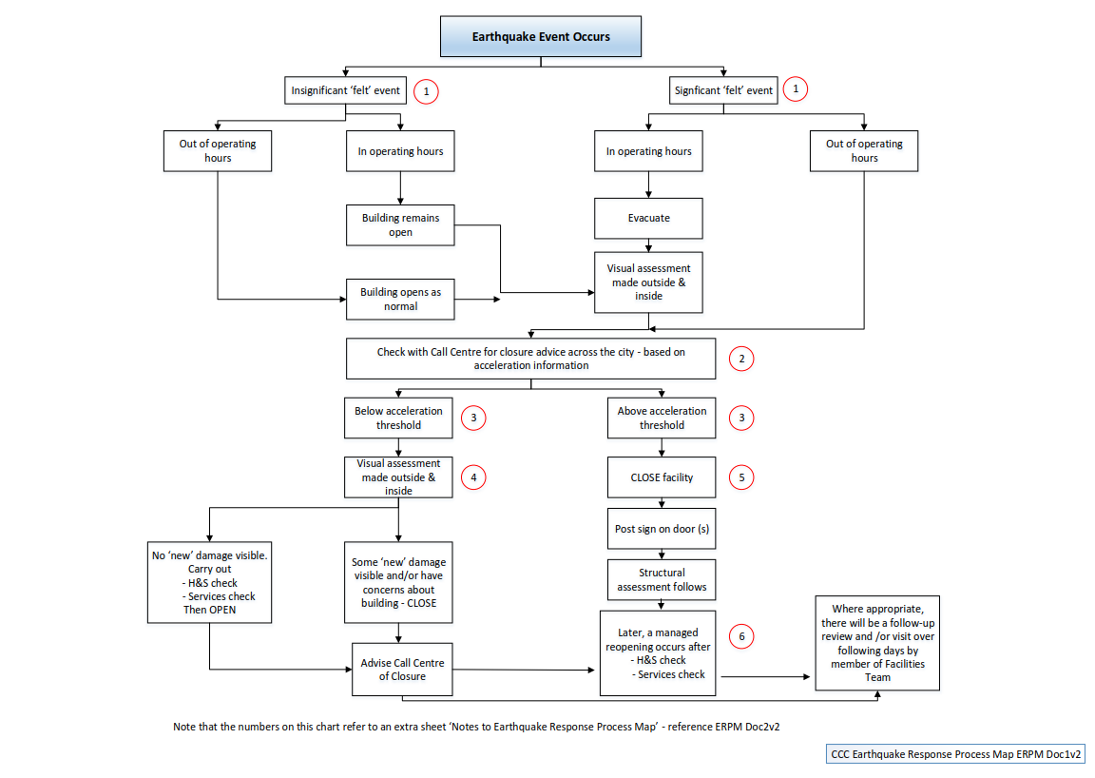

The ground acceleration data is reported in terms of 'g - the acceleration due to gravity'. Council's threshold for recommendation for closure of a building is 0.2g. This is the level of ground acceleration that is generally regarded as being where structural damage could start to occur and/or where liquefaction could start to occur (which can then give rise to foundation damage, settlement, underground utility damage etc).

